Introduction to Neural Networks
Neural networks are machine learning algorithms inspired by the human brain, designed to recognize underlying patterns in data.
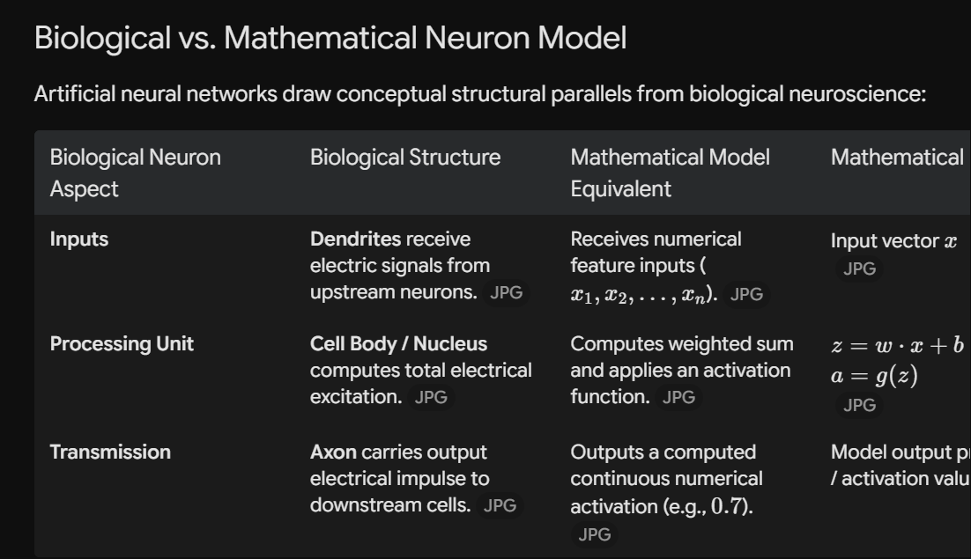

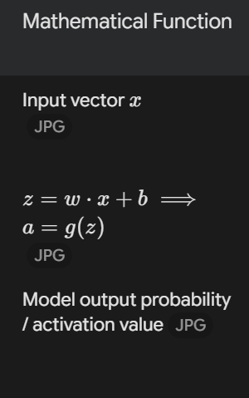

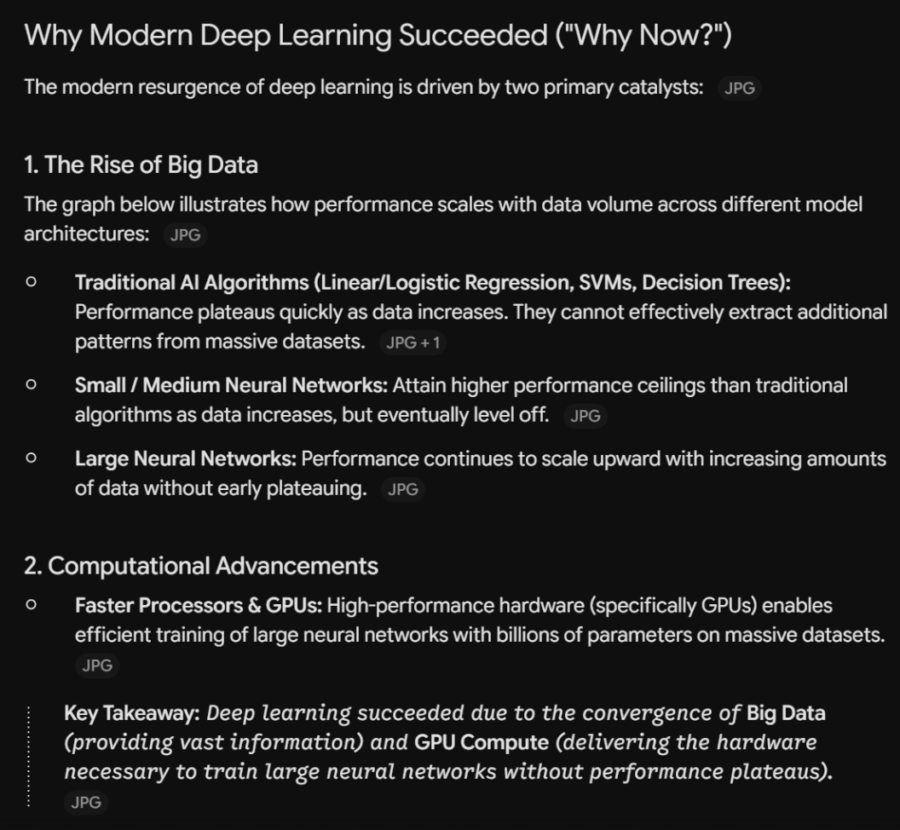

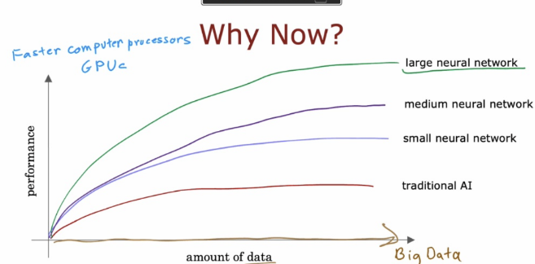

Neural Networks: Demand Prediction & Architectures
Explains how neural networks build complex abstractions from simple inputs, starting from a single neuron up to Multi-Layer Perceptrons (MLPs).

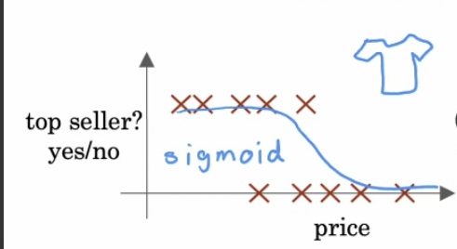
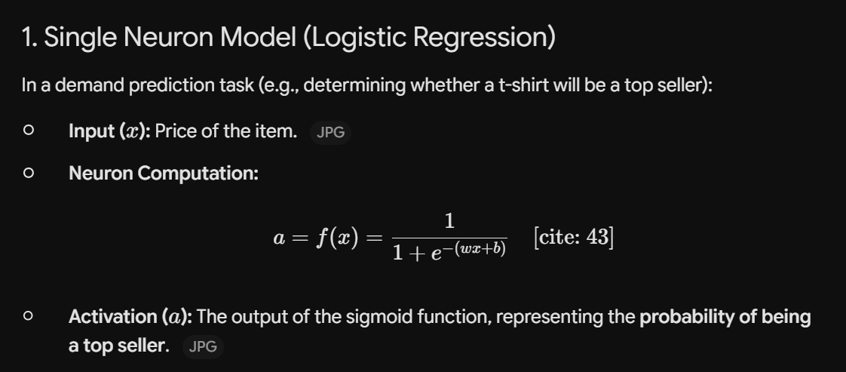
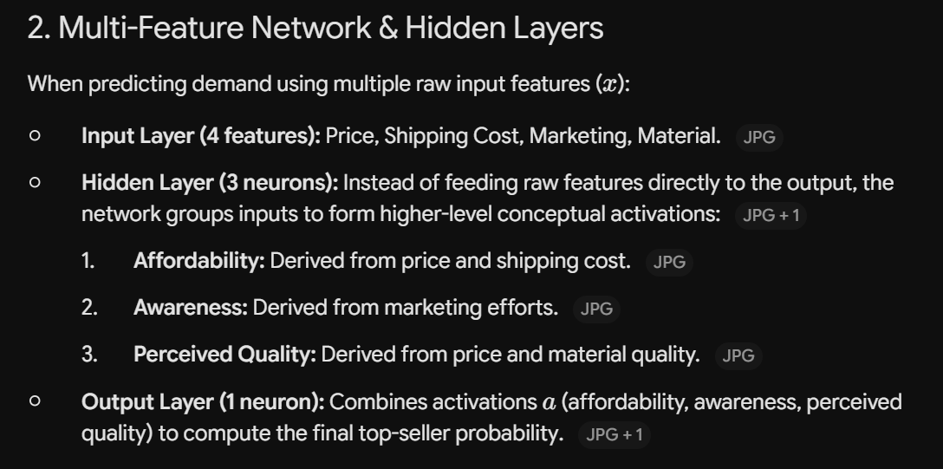
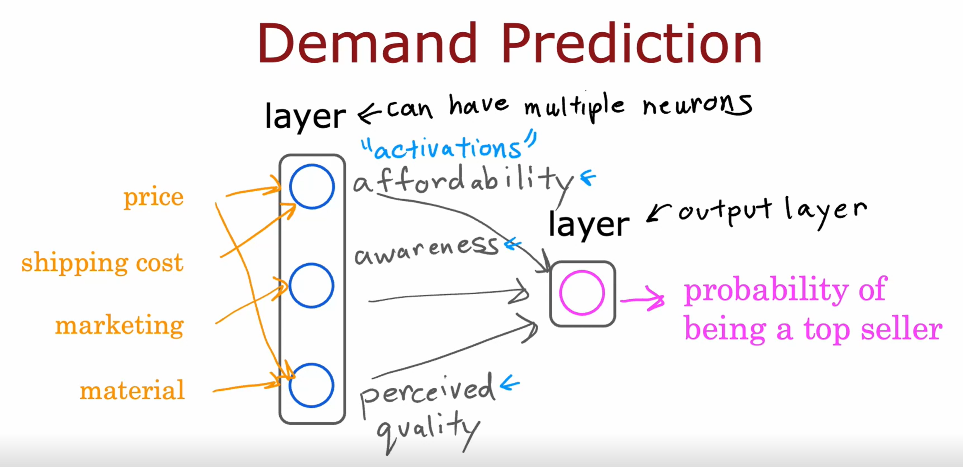
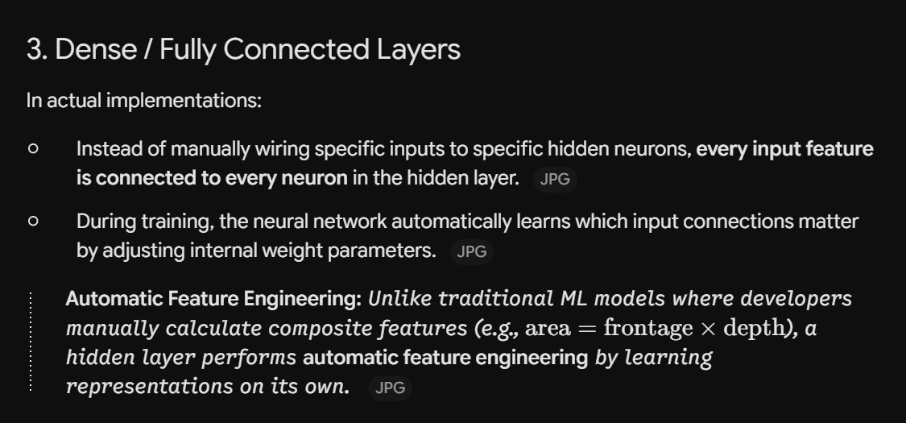
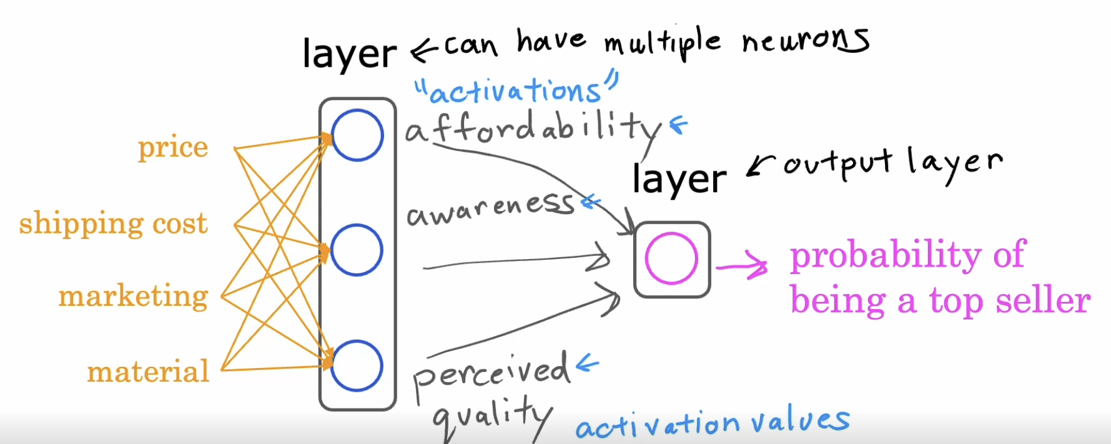


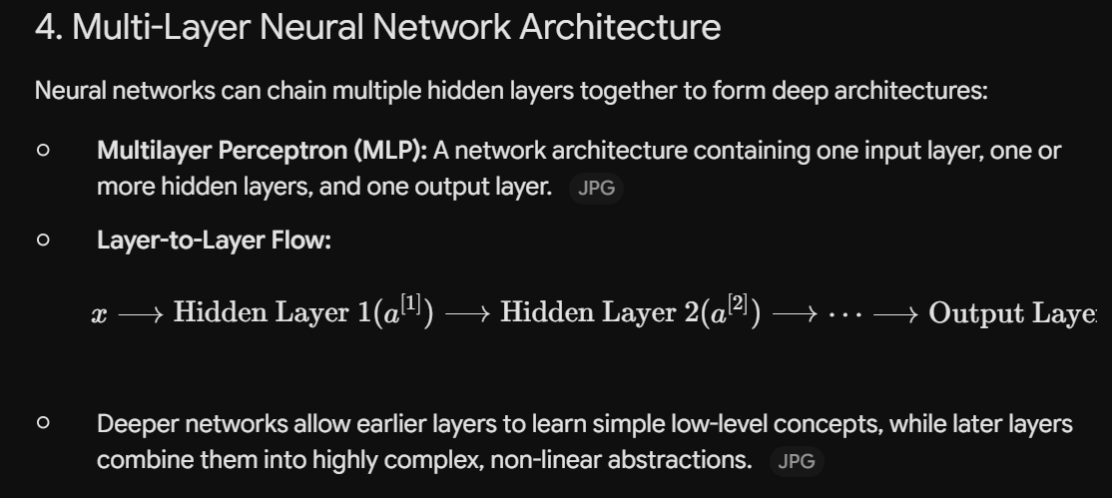
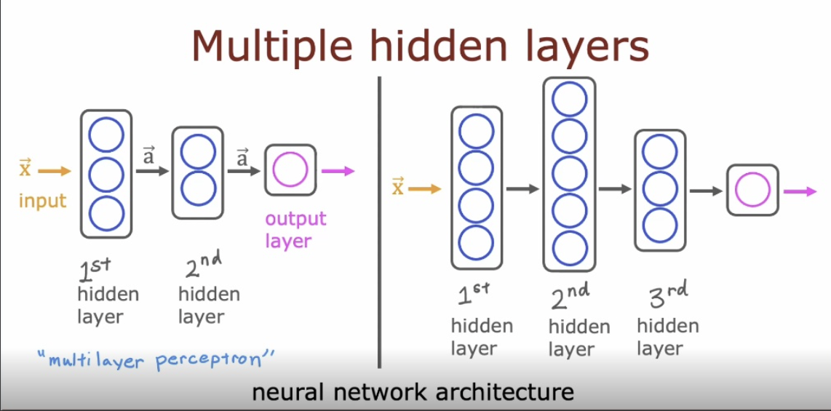
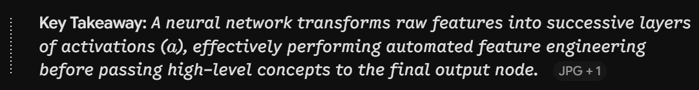

Face Recognition & Input Data Representation
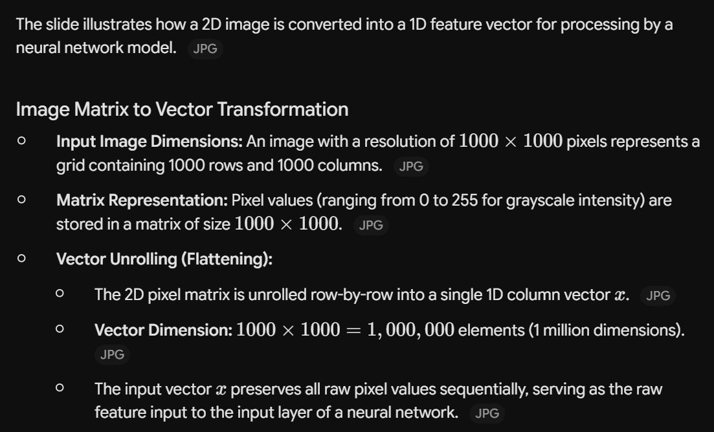
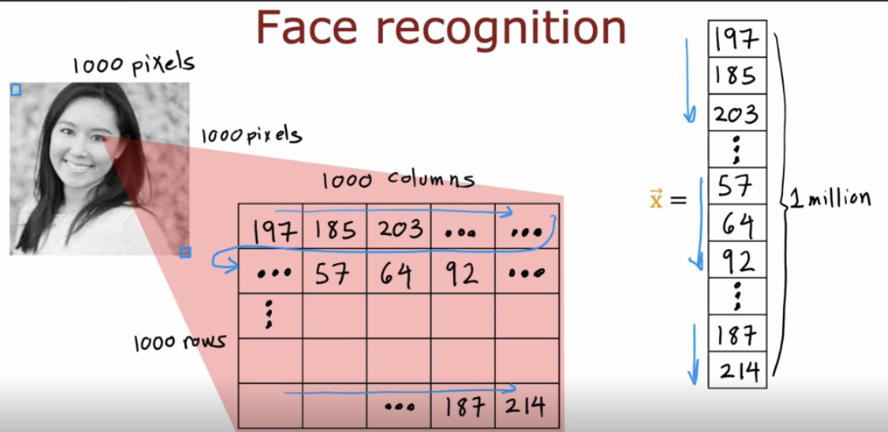
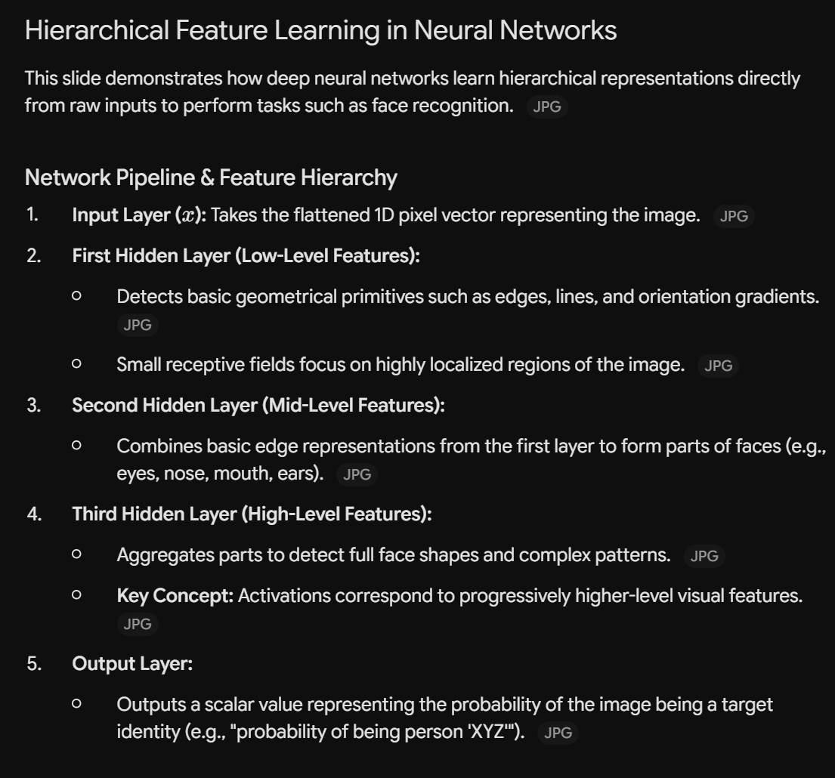
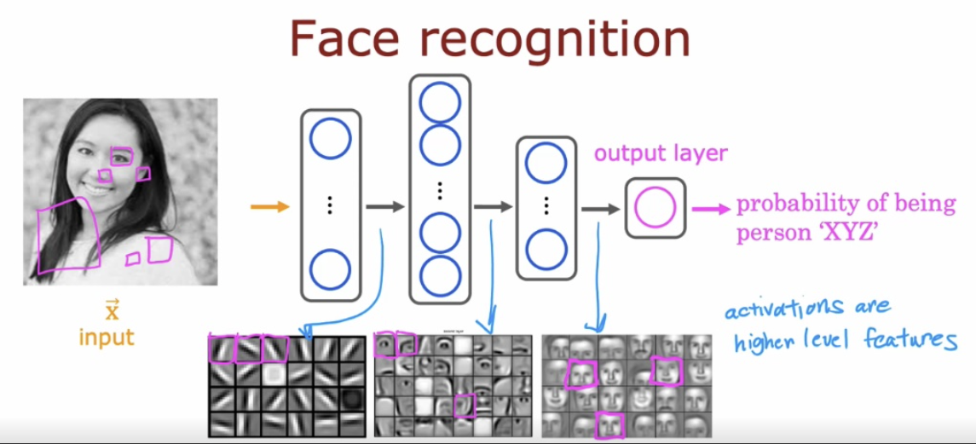
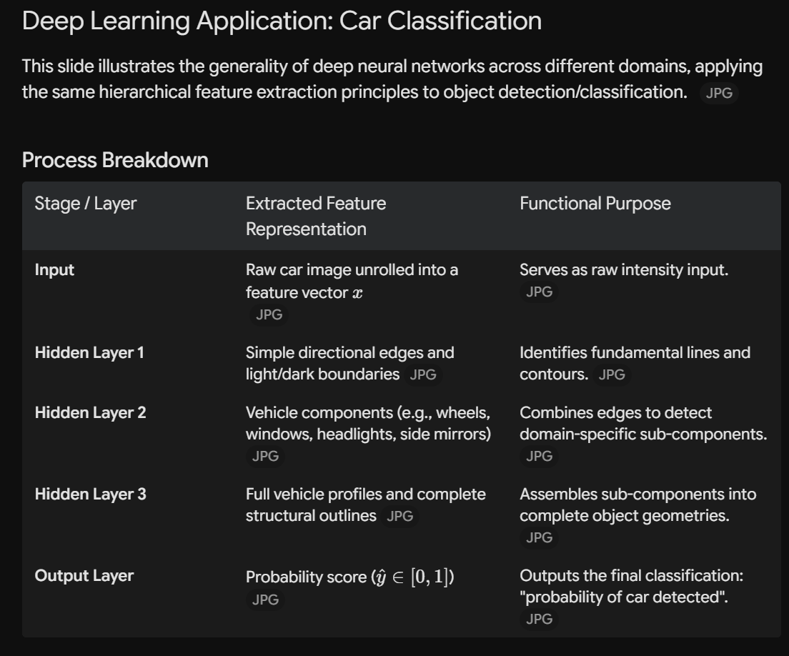
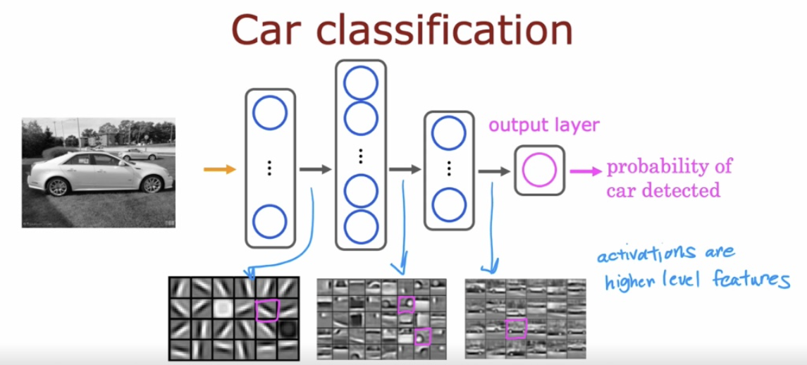
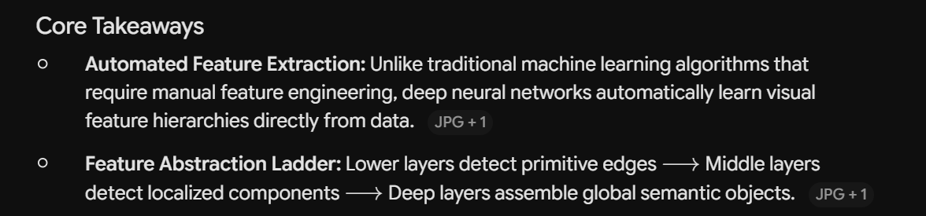

Neural Network Model
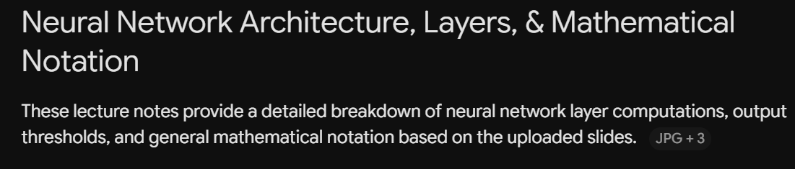
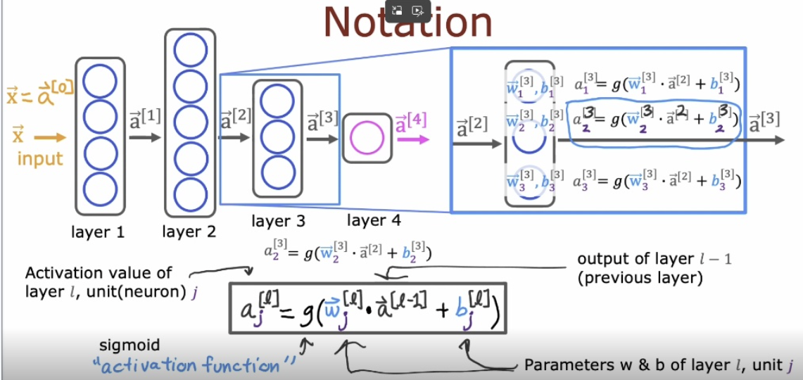
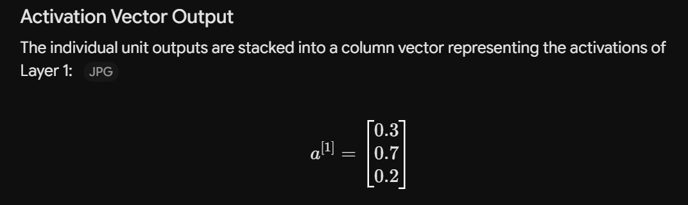
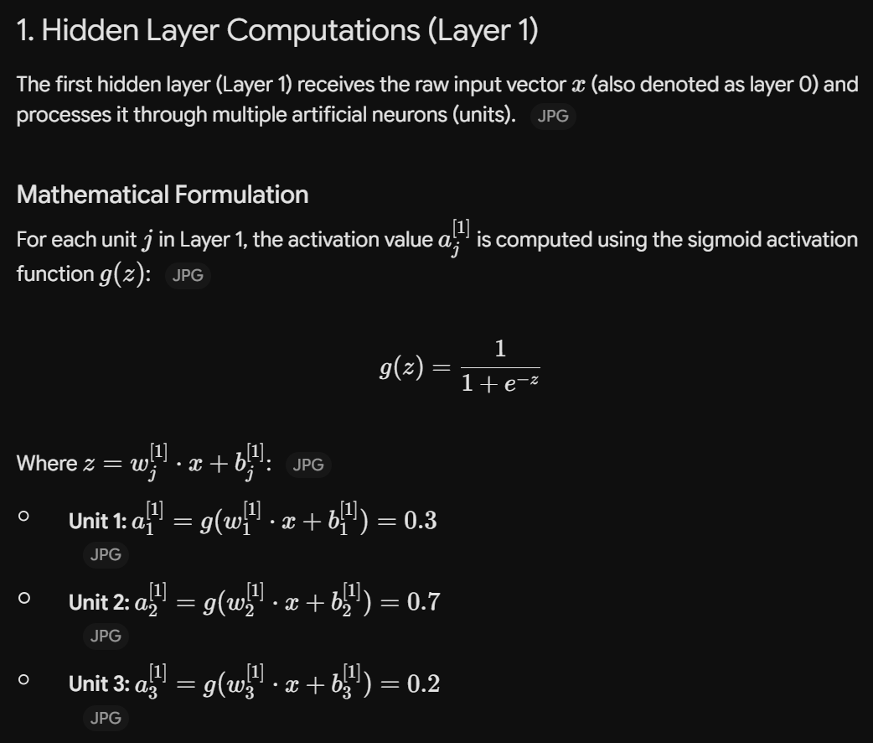

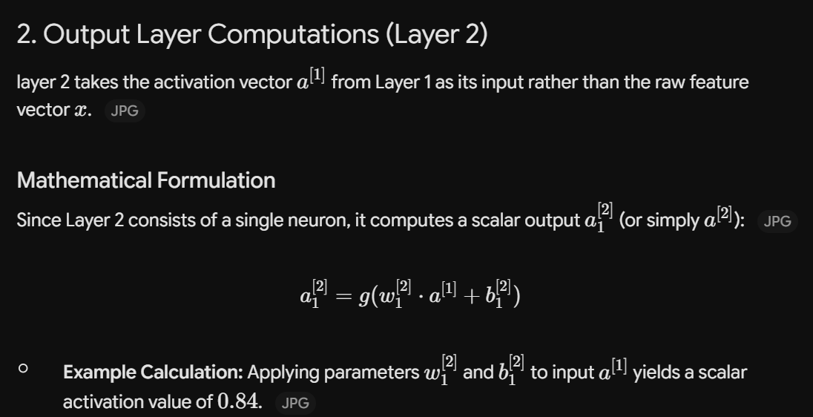
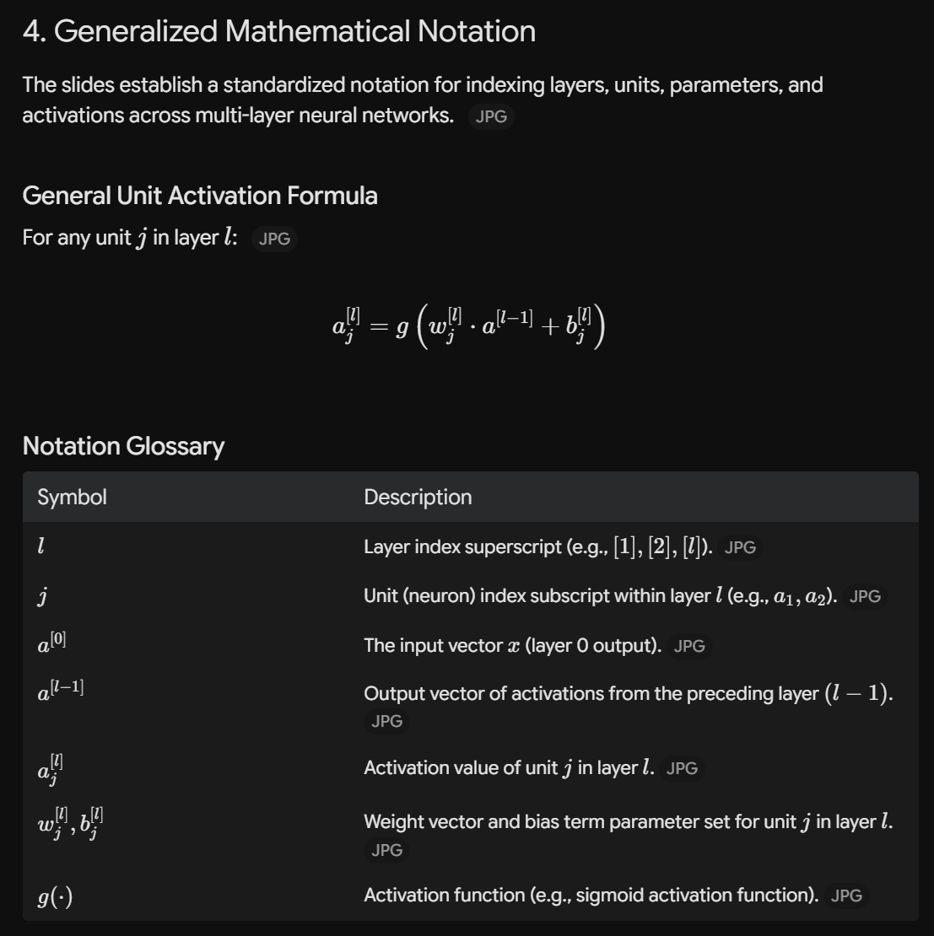
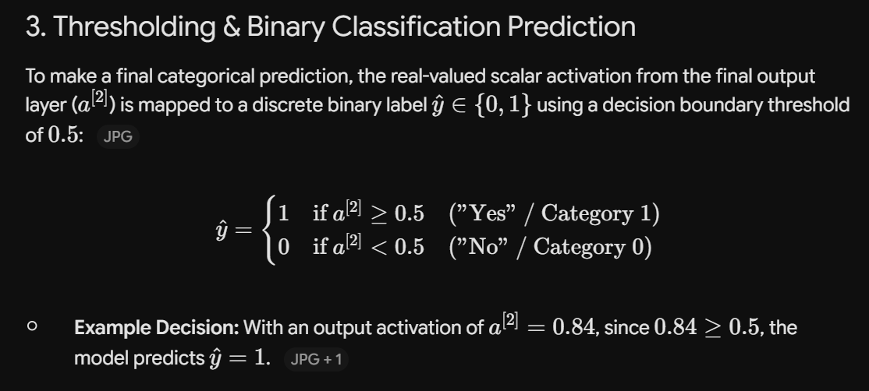

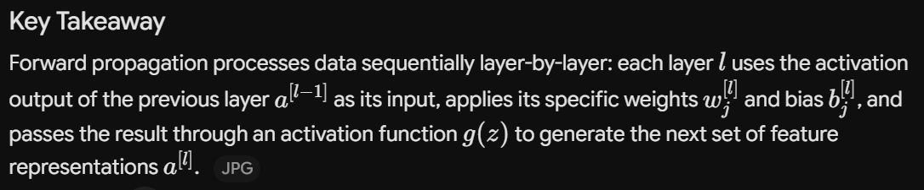
Handwritten Digit Recognition: Forward Propagation & Inference
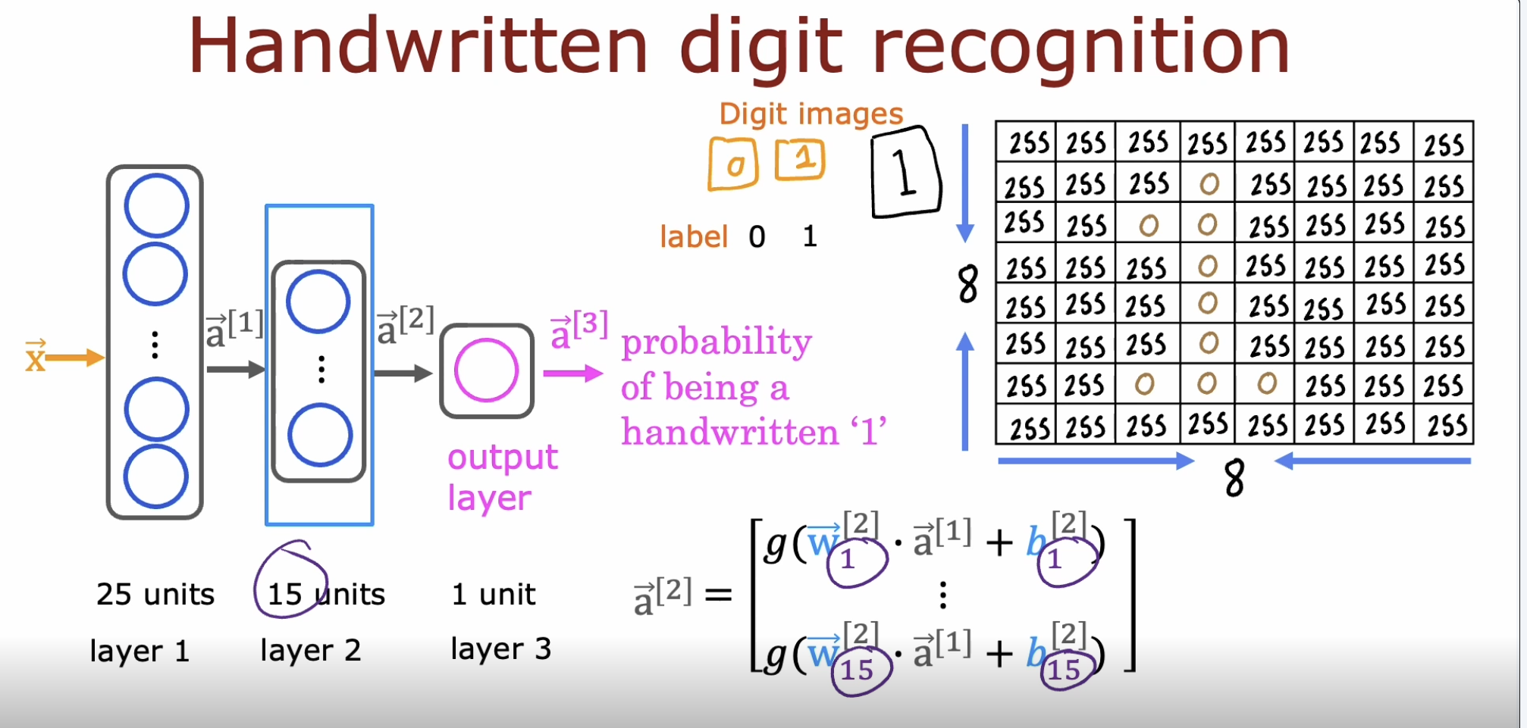
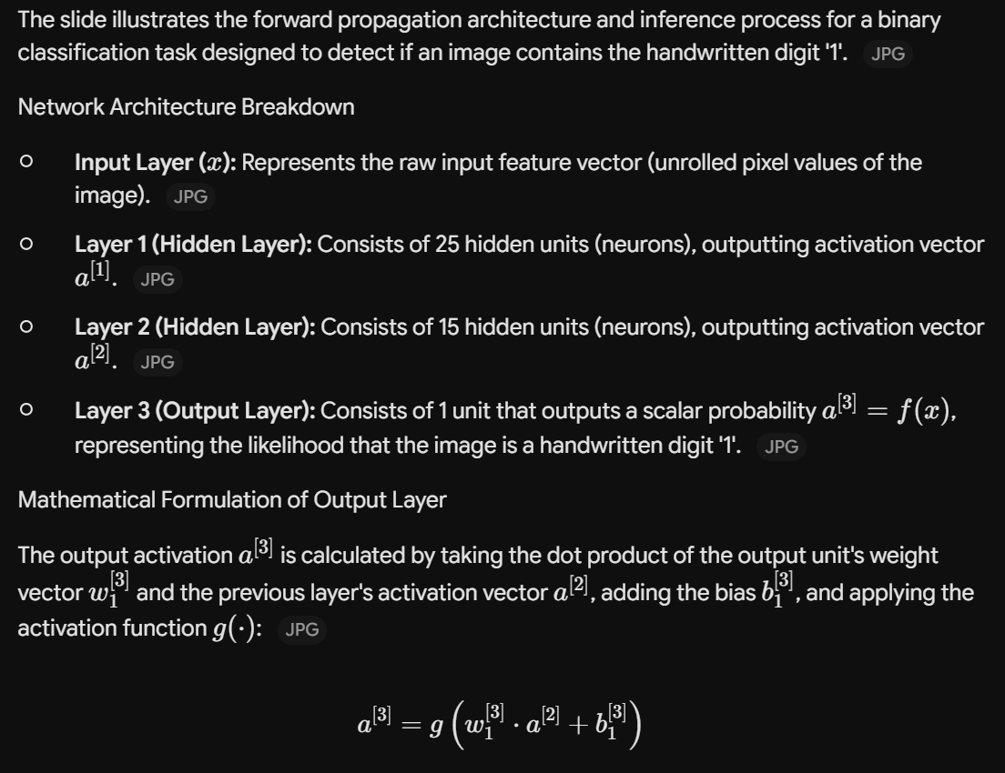
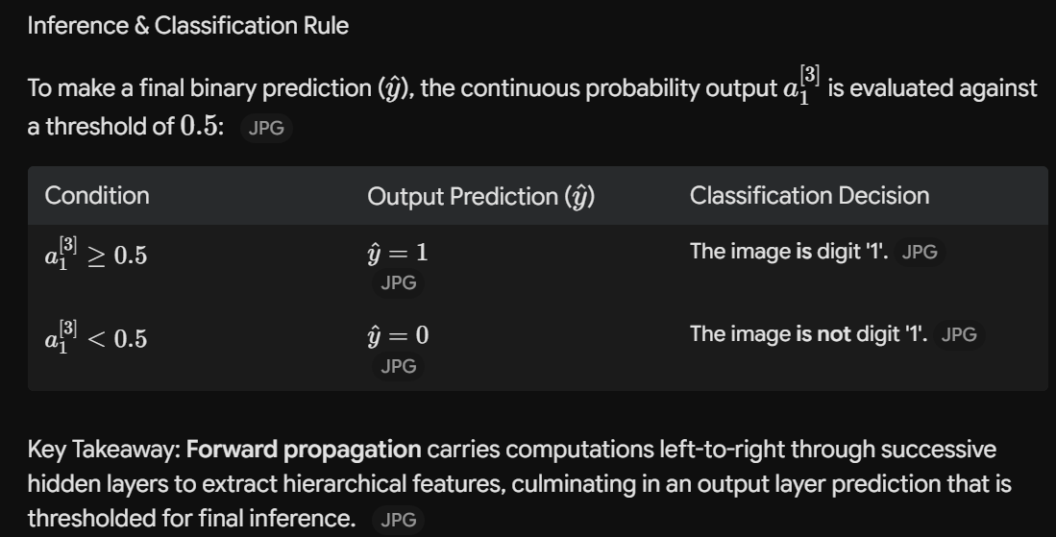
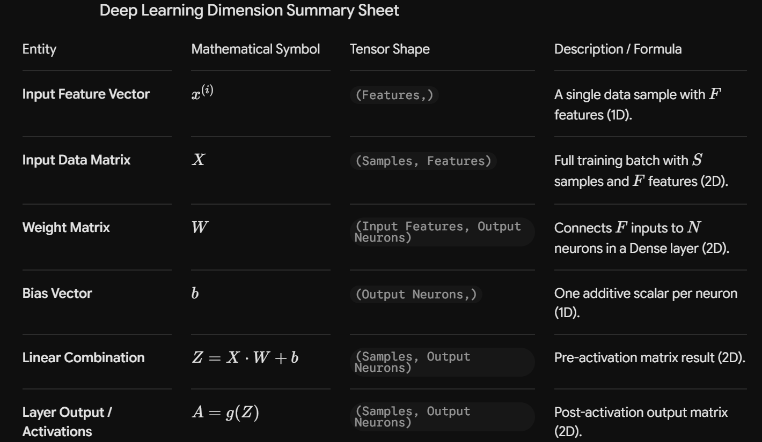
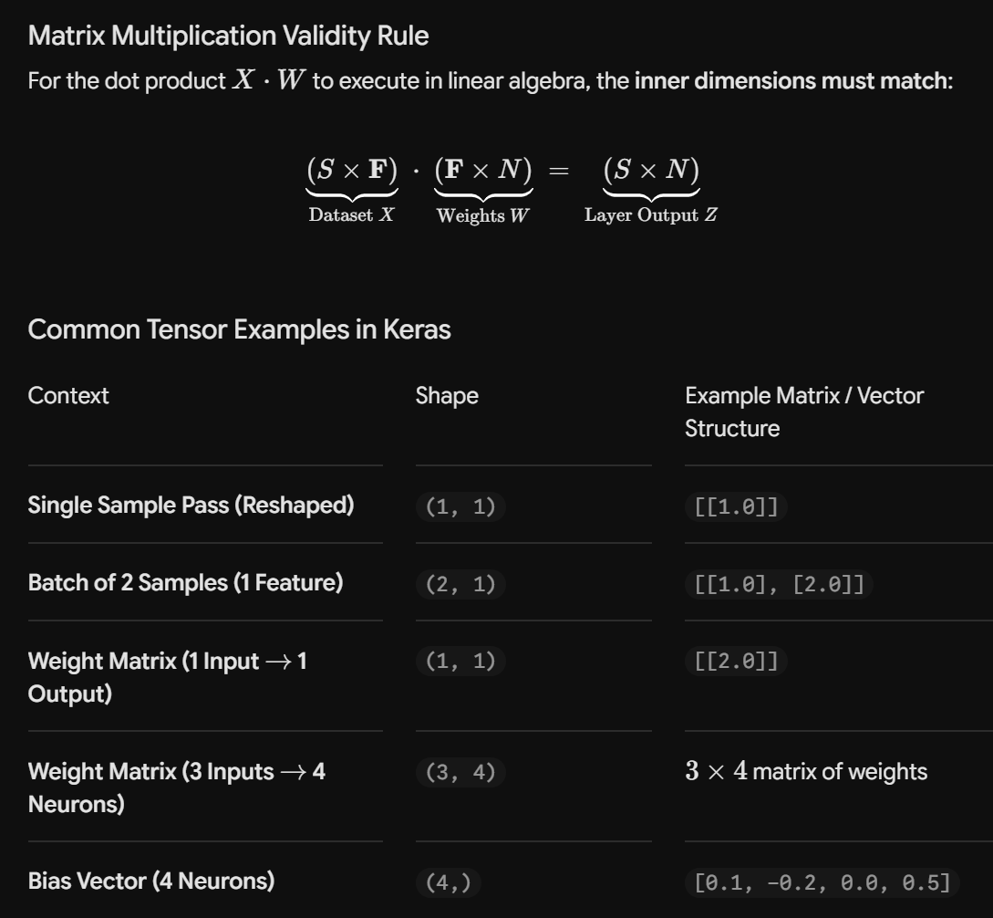
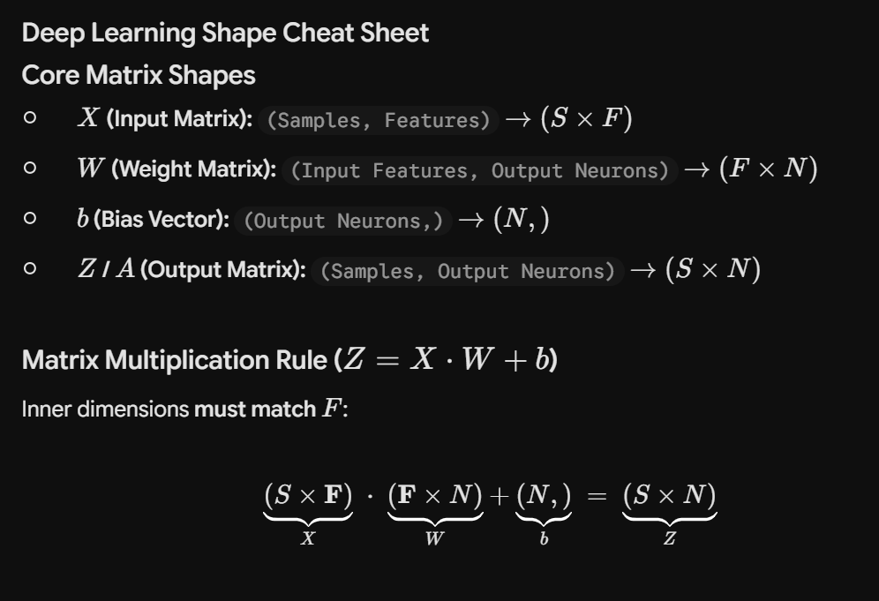
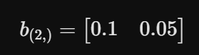
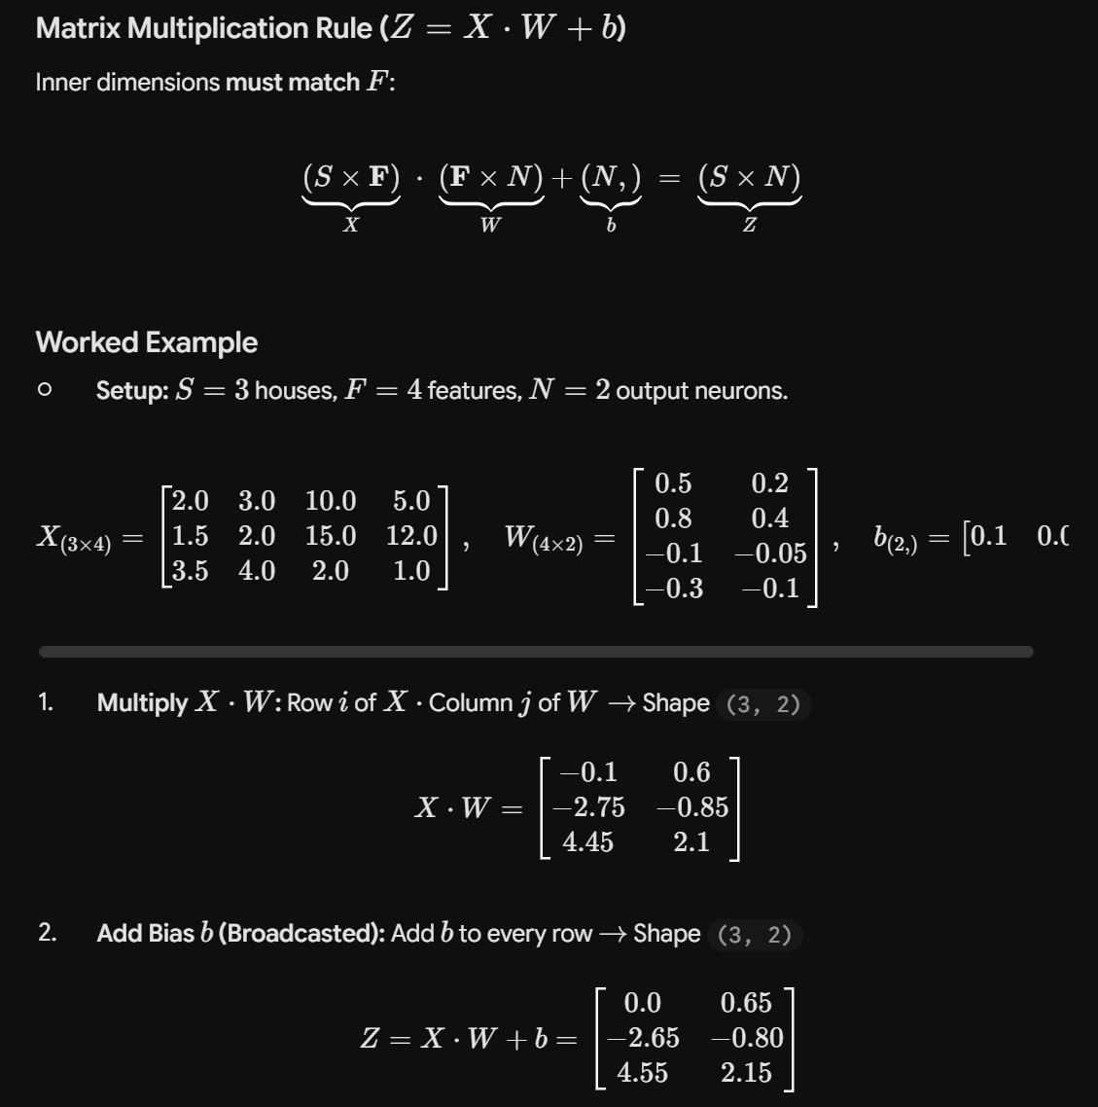

TensorFlow Inferencing
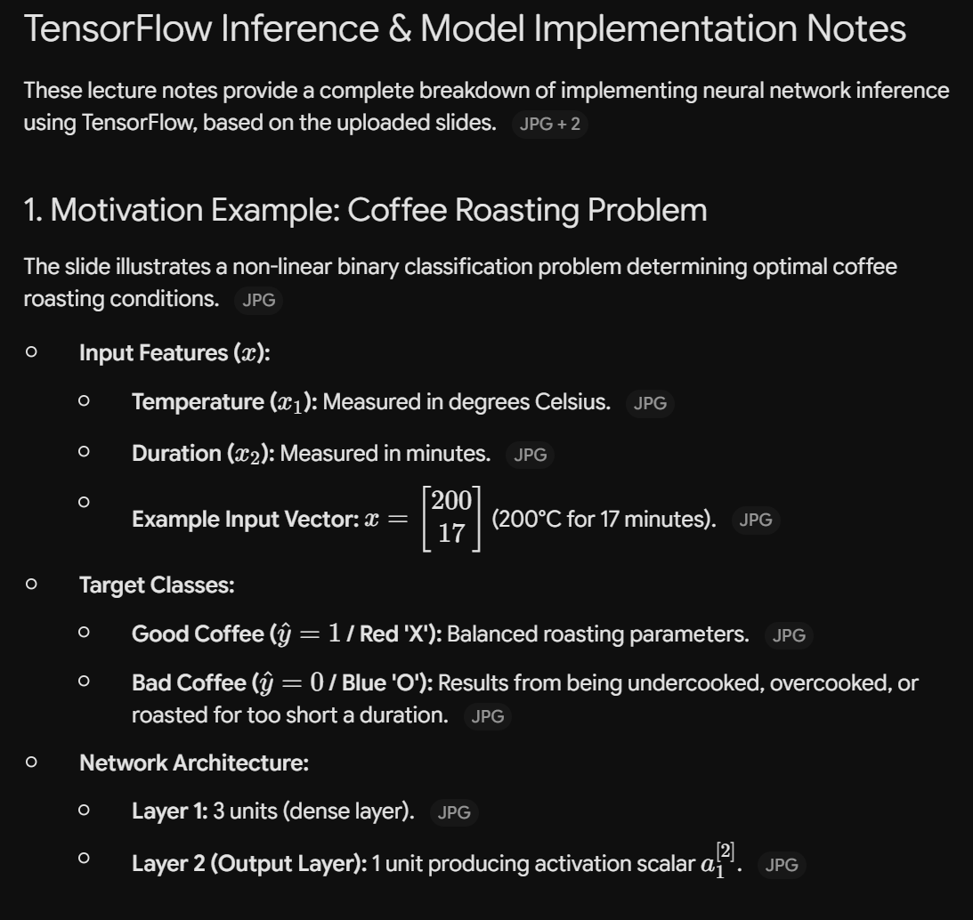
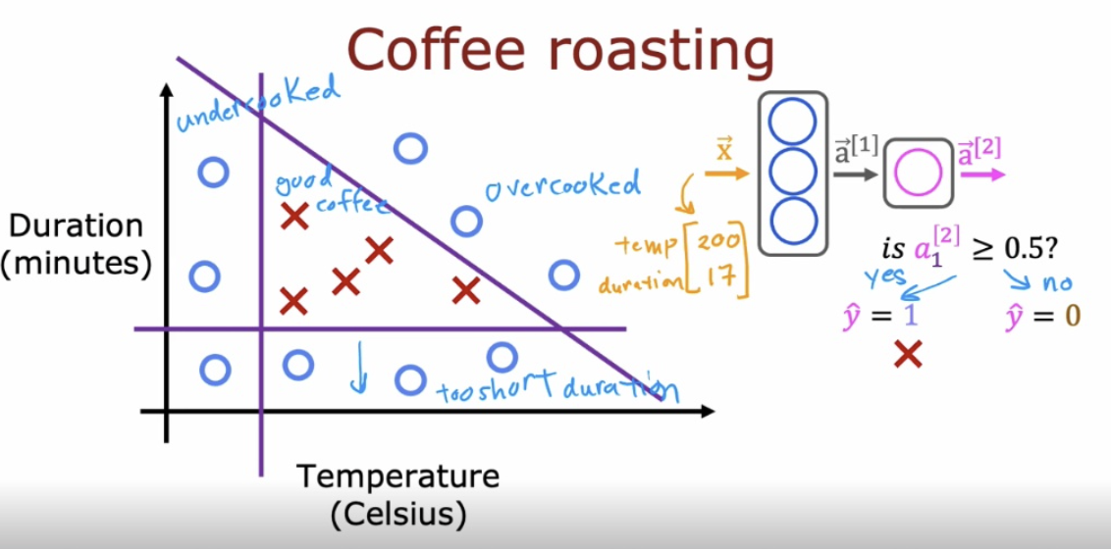

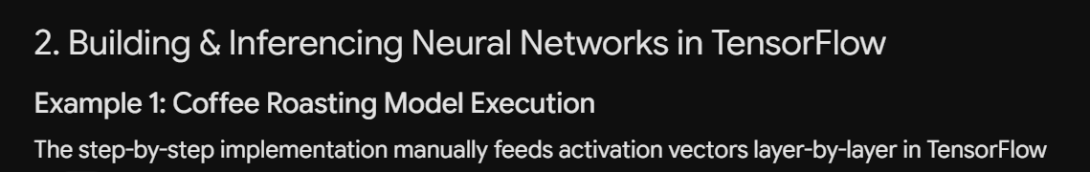
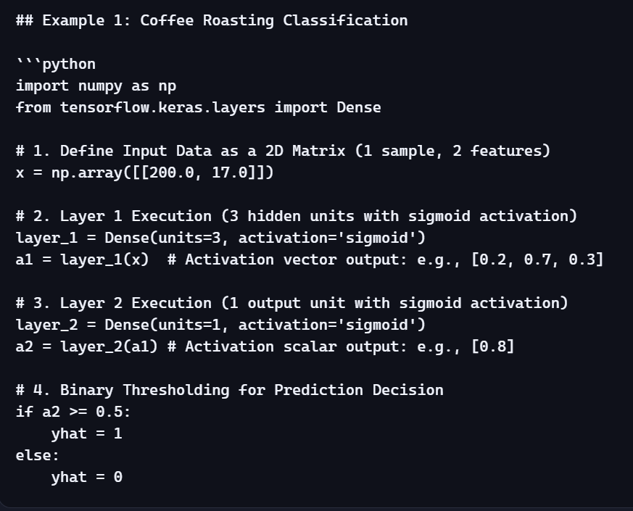

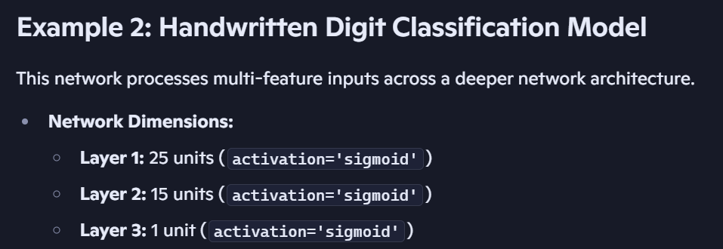
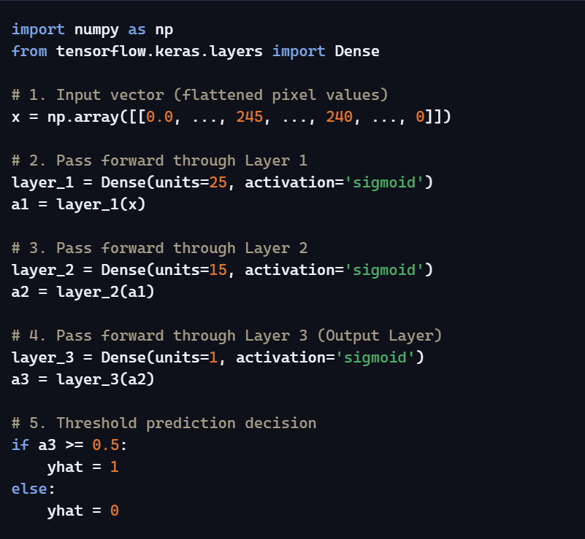
Model Task | Input Shape | Layer 1 Units | Layer 2 Units | Layer 3 Units | Threshold Condition
Coffee Roasting | $1×2$matrix $\left[200.0 , 17.0\right]$ | 3 (sigmoid) | 1 (sigmoid) | N/A | If $a^{\left[2\right]}≥0.5 ⟹ \hat{y}=1$
Digit Classification | $1×N$matrix $\left[0.0 , . , . , .240...\right]$ | 25 (sigmoid) | 15 (sigmoid) | 1 (sigmoid) | If $a^{\left[3\right]}≥0.5 ⟹ \hat{y}=1$

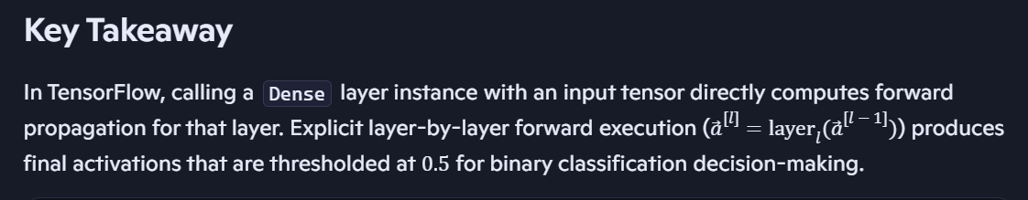

Data Representation in TensorFlow vs. NumPy
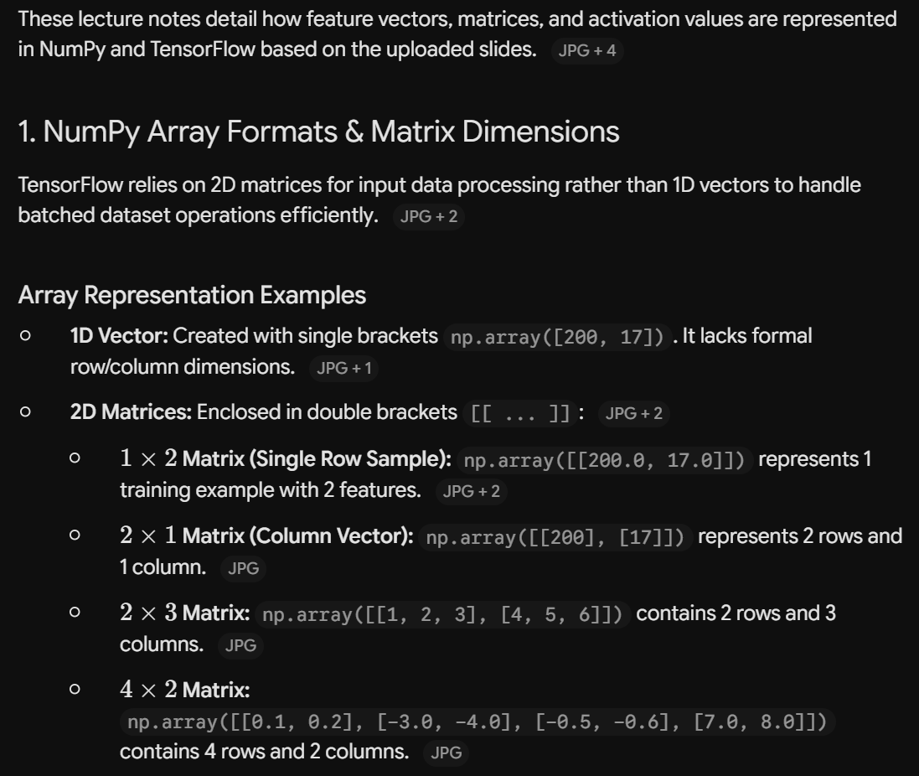
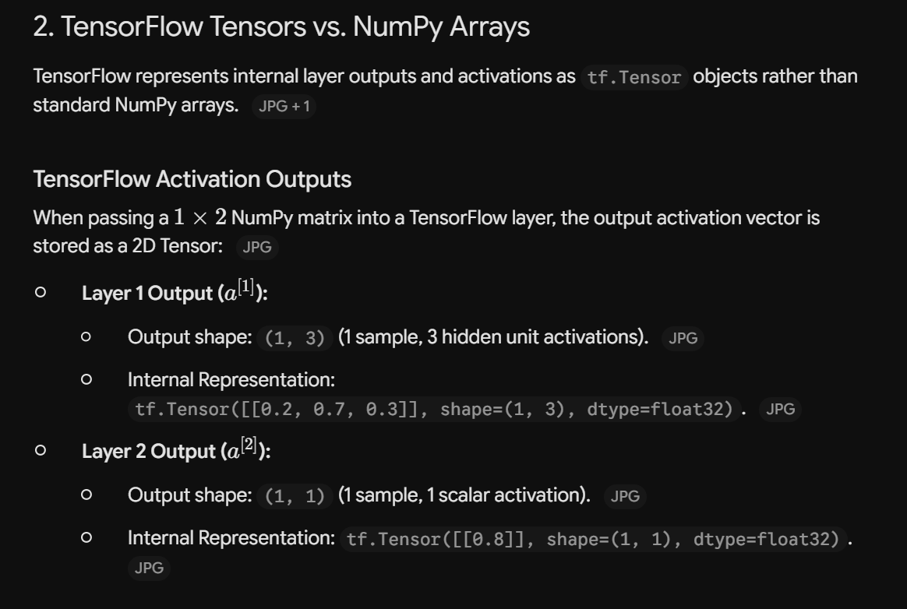
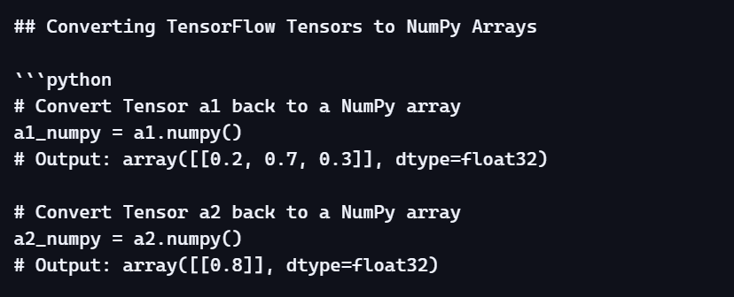
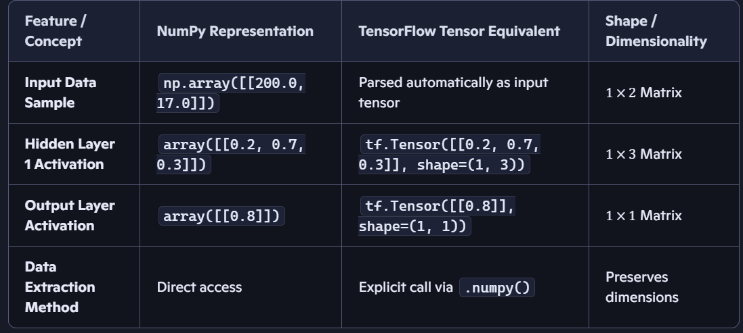

Building a Neural Network Architecture in Keras / TensorFlow

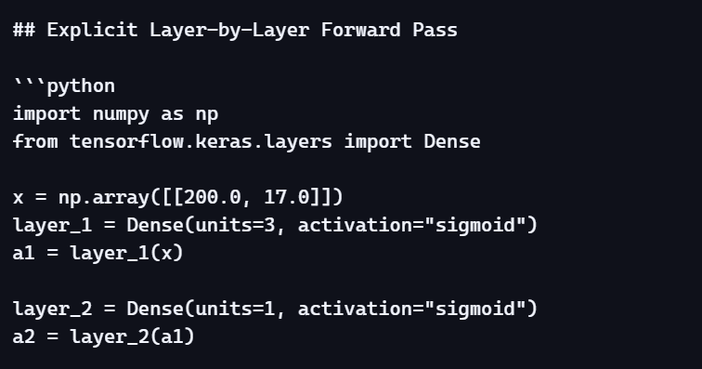
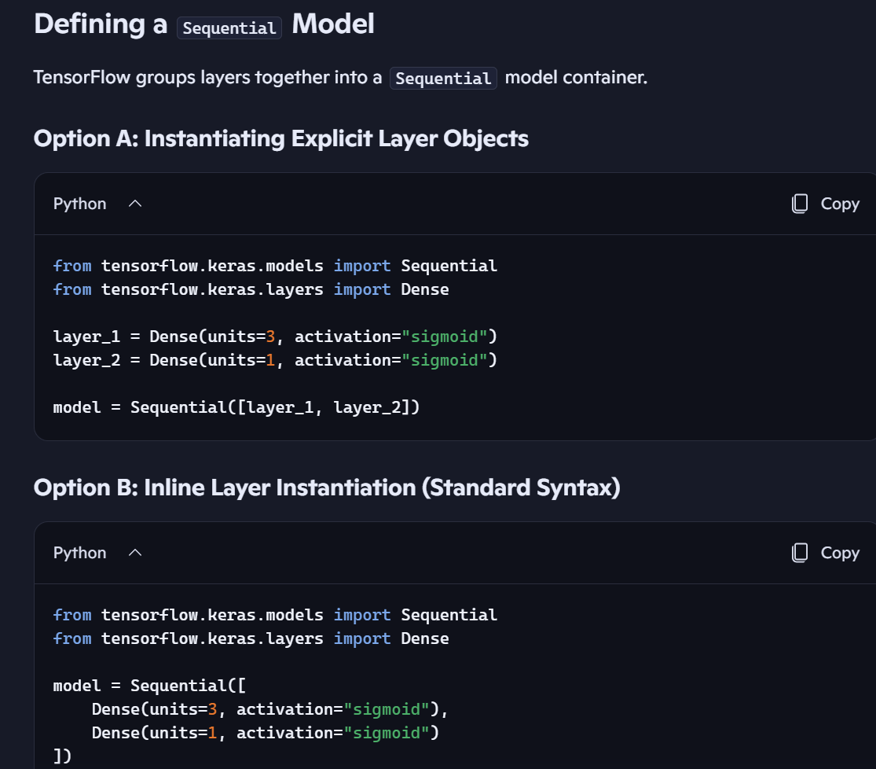
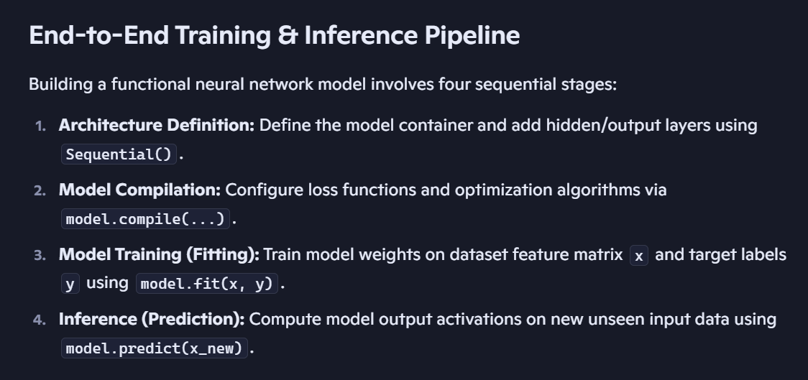
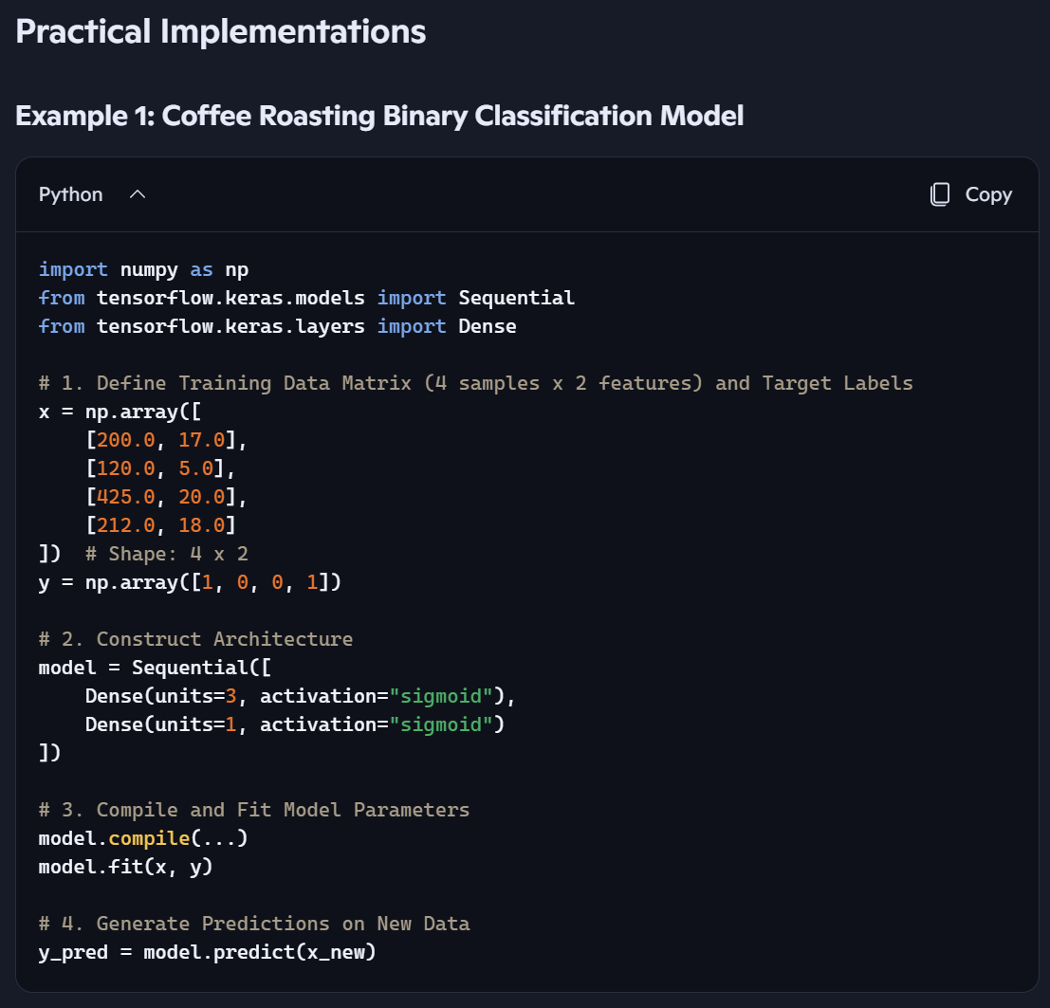
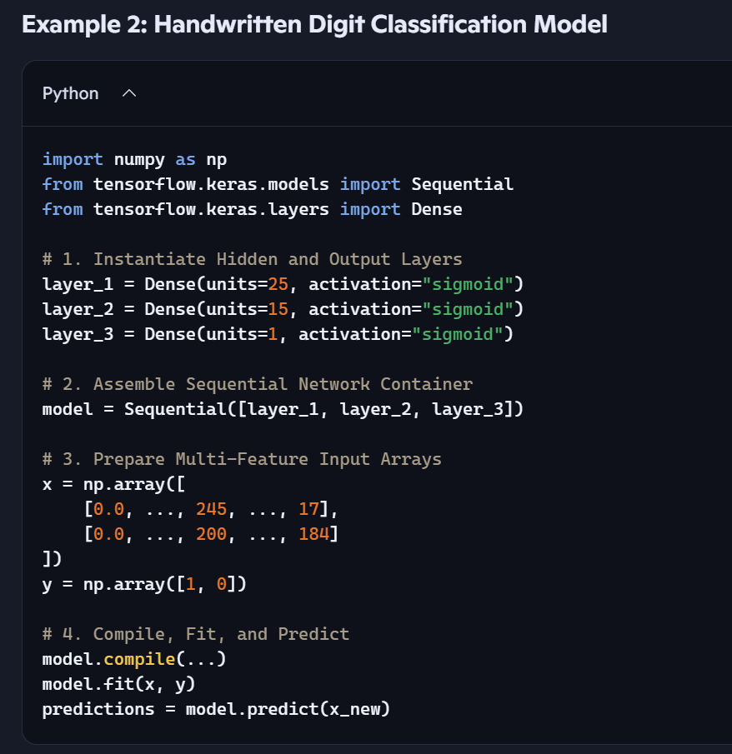
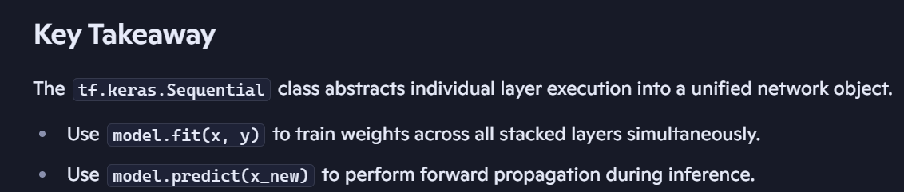
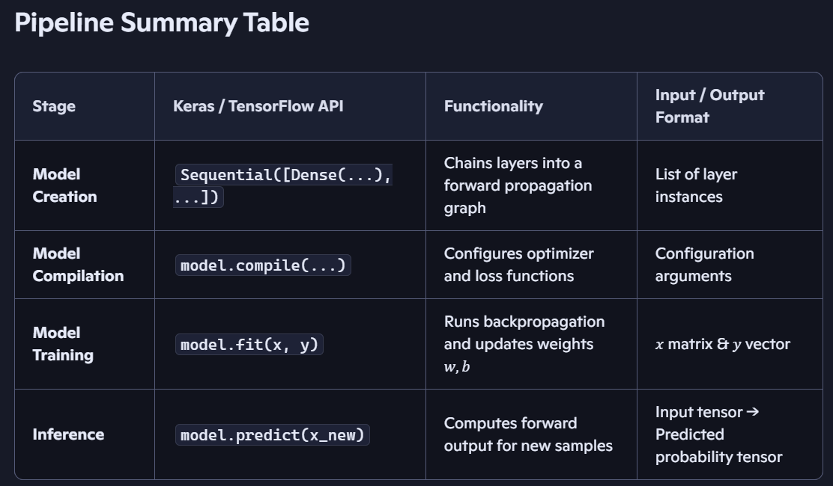

Forward Propagation in Python (Coffee Roasting Model)
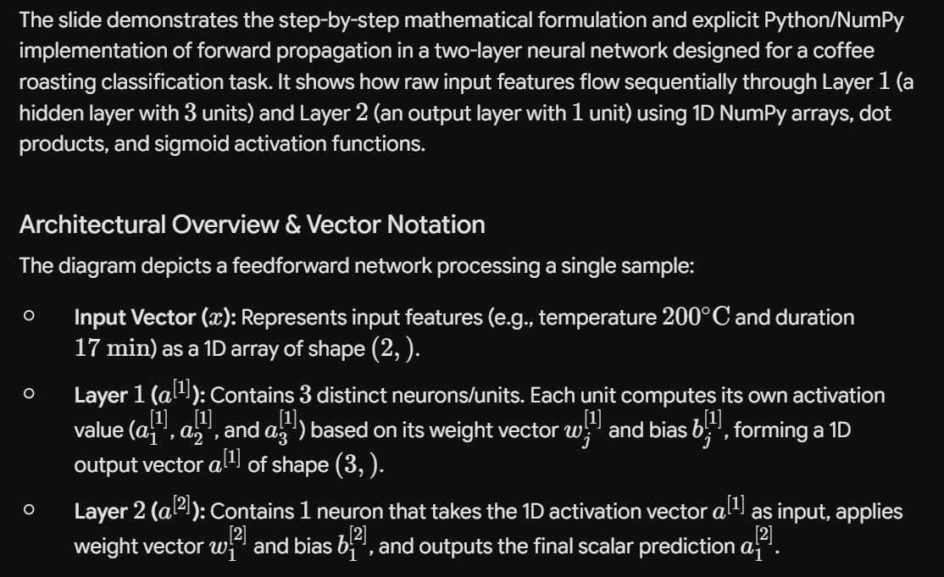
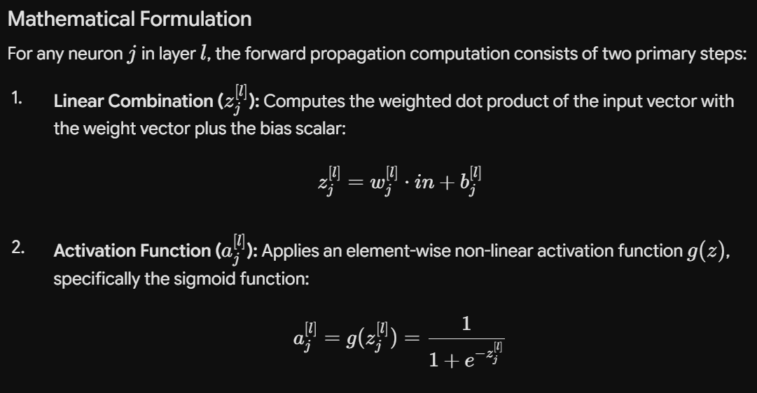
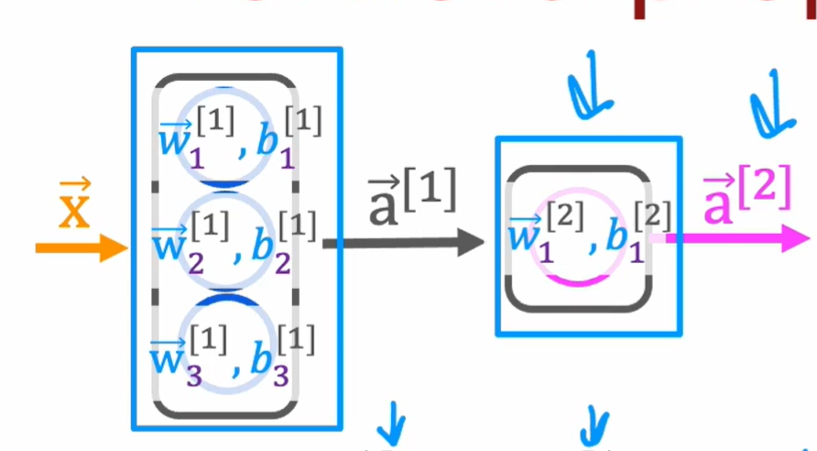
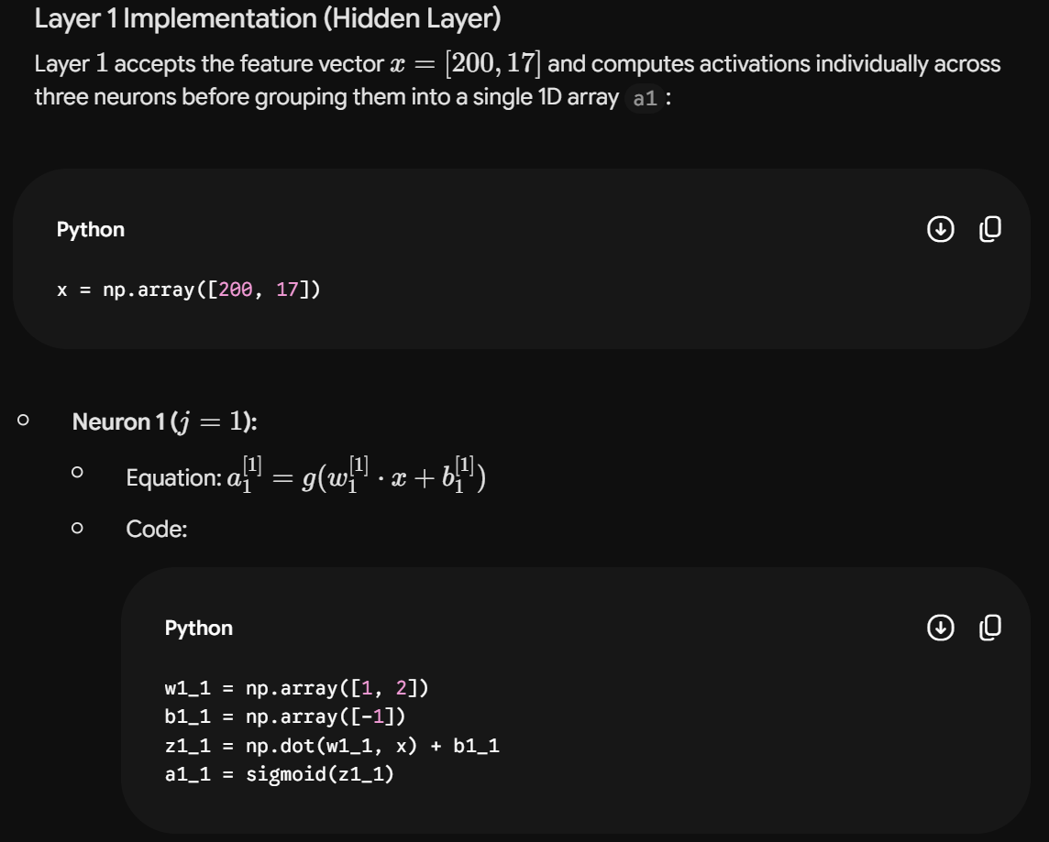
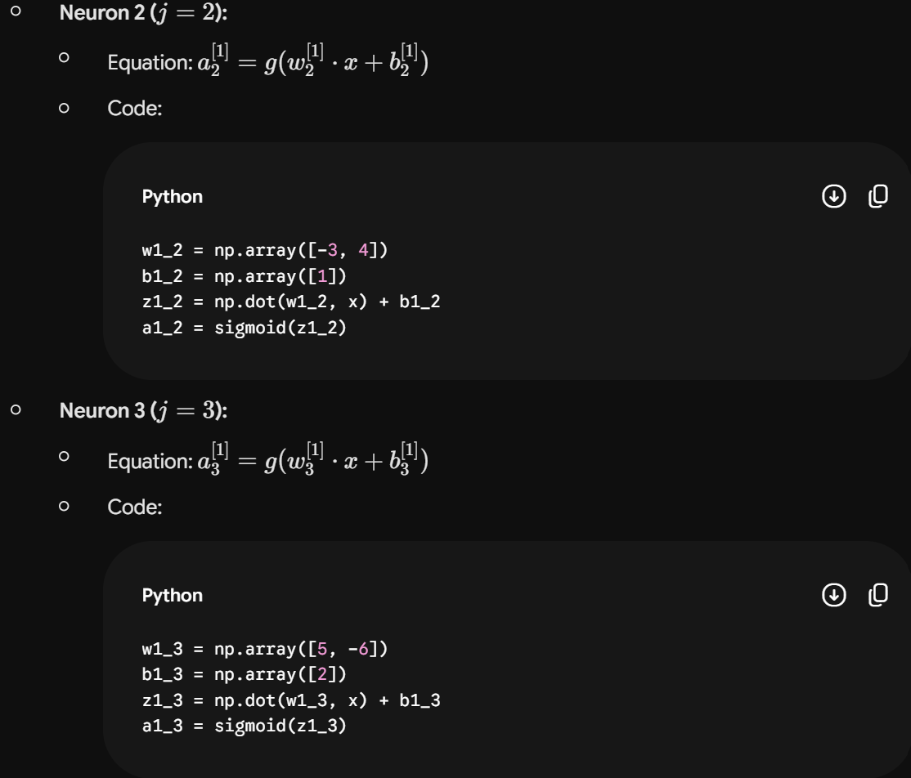
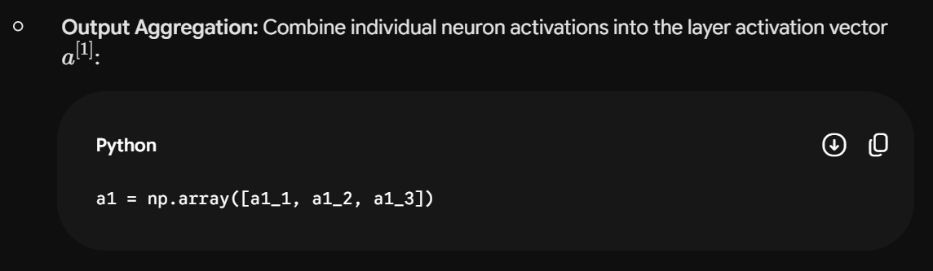
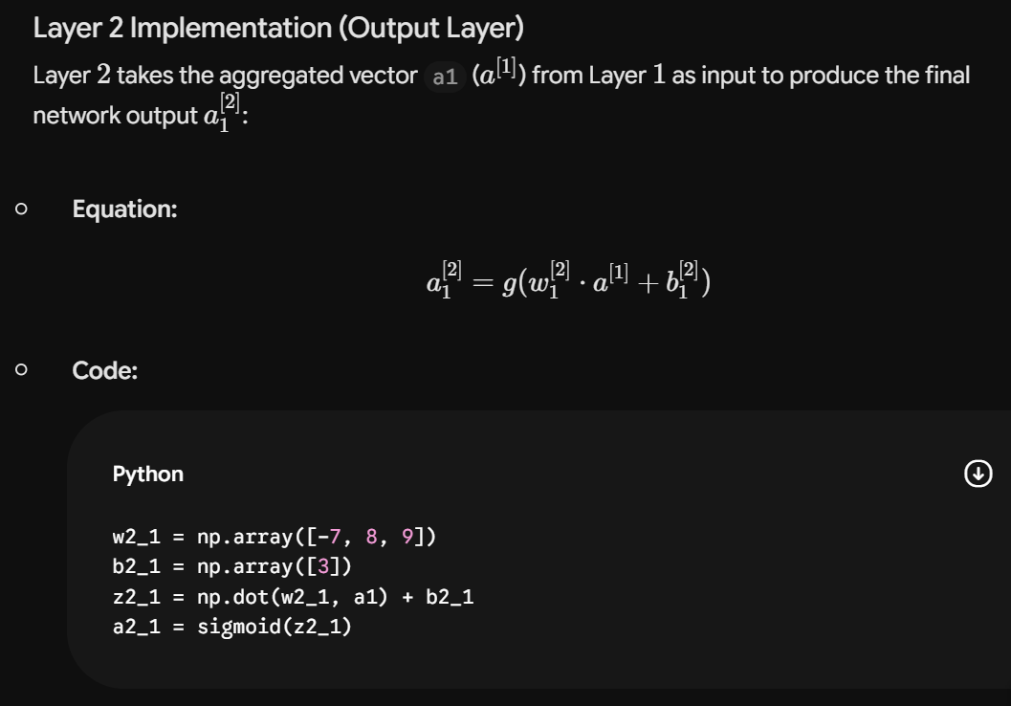
Layer | Neuron / Unit | Weight Vector (w) | Bias (b) | Dot Product Computation (z) | Activation Output (a)
Layer 1 | Unit 1 ($j=1$) | np.array([1, 2]) | np.array([-1]) | z1_1 = np.dot(w1_1, x) + b1_1 | a1_1 = sigmoid(z1_1)
Layer 1 | Unit 2 ($j=2$) | np.array([-3, 4]) | np.array([1]) | z1_2 = np.dot(w1_2, x) + b1_2 | a1_2 = sigmoid(z1_2)
Layer 1 | Unit 3 ($j=3$) | np.array([5, -6]) | np.array([2]) | z1_3 = np.dot(w1_3, x) + b1_3 | a1_3 = sigmoid(z1_3)
Layer 2 | Unit 1 ($j=1$) | np.array([-7, 8, 9]) | np.array([3]) | z2_1 = np.dot(w2_1, a1) + b2_1 | a2_1 = sigmoid(z2_1)
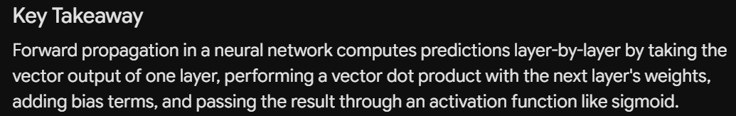

Code Implementation:
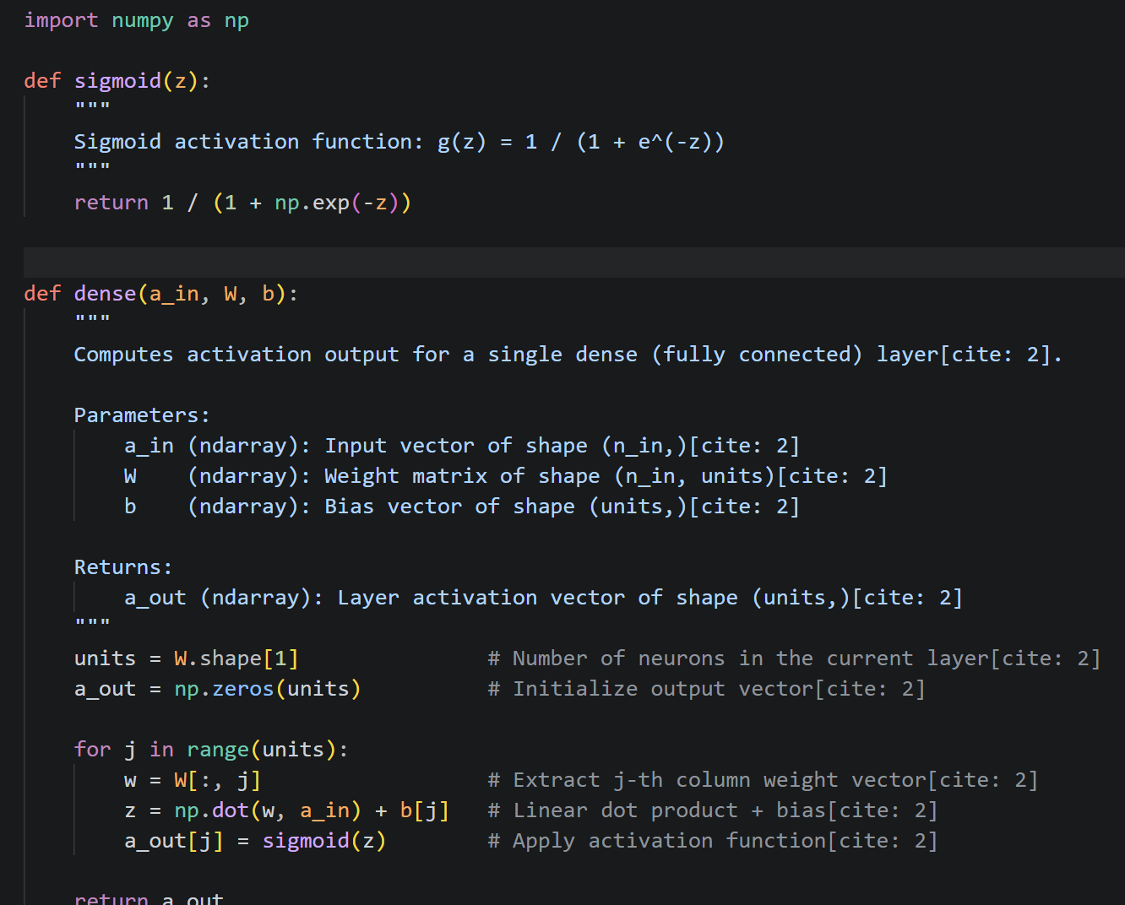
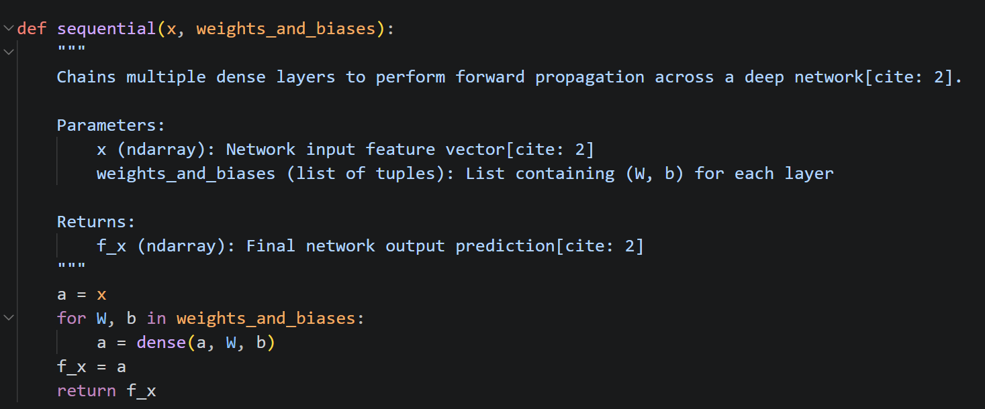
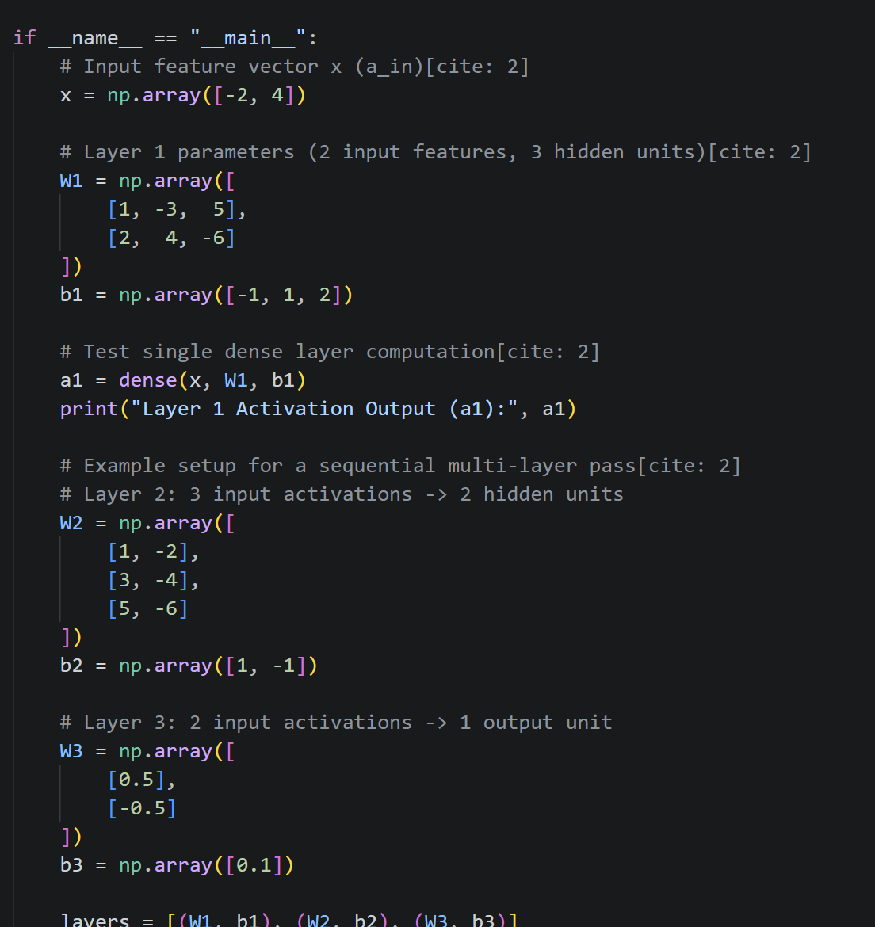

AI Spectrum: Artificial Narrow Intelligence (ANI) vs. Artificial General Intelligence (AGI)

The slide displays a hierarchical taxonomy of Artificial Intelligence (AI), categorizing AI technology into two distinct branches based on capability and scope: Artificial Narrow Intelligence (ANI) and Artificial General Intelligence (AGI).
Taxonomy Breakdown
- AI (Artificial Intelligence): The root domain encompassing synthetic systems designed to perform intellectual tasks.
- ANI (Artificial Narrow Intelligence): Specialized AI systems trained to perform specific, predefined tasks within a constrained domain.
- AGI (Artificial General Intelligence): Theoretical AI systems possessing broad cognitive abilities equivalent to human intelligence, capable of performing any intellectual task a human can do.

Categorization and Examples
AI Type | Definition | Key Real-World Examples
ANI (Narrow) | Systems engineered for single or limited tasks. | Smart speakers, self-driving cars, web search engines, AI in agriculture, AI in manufacturing/factories.
AGI (General) | Systems capable of versatile, human-level reasoning. | Theoretical systems capable of doing anything a human can do.
Key Takeaway: Current deployed AI technologies belong entirely to Artificial Narrow Intelligence (ANI), while Artificial General Intelligence (AGI) remains the goal of creating AI that matches the full cognitive breadth of a human.

Neural Networks and the Human Brain

The slide examines the relationship between biological brains and artificial neural networks, addressing the fundamental question of whether machine learning models truly mimic human brain function.

Biological vs. Artificial Comparison
- Biological Neuron: Composed of physical cellular structures including the cell body, nucleus, dendrites (input receivers), and axon (output transmitter).
- Artificial Neuron Model: Represented as a mathematical function node taking an input vector $\vec{x}$ and producing a processed scalar/vector output $f\left(\vec{x}\right)$.
Core Distinction
- Current Understanding: Despite historical inspiration drawn from neuroscience, artificial neural networks are simplified mathematical abstractions.
- Scientific Constraint: As noted on the slide, science currently has "(almost) no idea how the brain works" at a complete algorithmic level.

Key Takeaway: Artificial neural networks are loosely inspired by biological brains, but they are mathematical functions rather than direct simulations of human neurobiology.

Biological Neurons vs. Simplified Mathematical Models
The slide presents a side-by-side structural comparison contrasting a biological neuron's signal processing with a simplified artificial mathematical neuron.
Structural Mapping
Component | Biological Neuron | Simplified Mathematical Neuron
Input Mechanism | Dendrites receive electrochemical signals from preceding cells. | Numerical input features (e.g., scalar value $2$ or vector inputs) fed into the node.
Processing Center | Cell Body and Nucleus integrate incoming electrical potentials. | Mathematical processing unit computing weighted sums and activation functions.
Output Mechanism | Axon transmits output pulses to another neuron. | Numerical output value (e.g., activation value $0.7$) passed forward to subsequent nodes.
Mathematical Abstraction
- Biological chemical neurotransmission is abstracted into pure scalar numbers (e.g., input $2→\text{Neuron Node}→\text{output }0.7$).
- Multiple interconnected mathematical nodes form artificial neural networks mimicking signal flow across biological pathways.
Key Takeaway: An artificial neuron abstracts complex biological neurobiology into numerical inputs, mathematical operations, and numerical outputs passed to subsequent units.

The "One Learning Algorithm" Hypothesis: Auditory Cortex Re-wiring
The slide illustrates experimental evidence supporting the "One Learning Algorithm" hypothesis in neuroscience, referencing work by Roe et al. (1992).
Experimental Concept
- Hypothesis: The tissue of the cerebral cortex may run a single, general-purpose learning algorithm regardless of which sensory input it receives.
- Rewiring Experiment:
  - The natural connection from the ear to the auditory cortex was severed/severely altered (marked by red $X$).
  - Visual signals from the eye were rerouted directly into the auditory cortex.
- Result: The auditory cortex learns to see, processing visual input despite originally being dedicated to hearing.

Key Takeaway: Cortical tissue is highly adaptable; when supplied with visual input, auditory brain regions naturally learn to process vision, supporting the hypothesis of a unified cortical learning mechanism.

The "One Learning Algorithm" Hypothesis: Somatosensory Cortex Re-wiring
The slide demonstrates another instance of the "One Learning Algorithm" hypothesis focusing on the somatosensory cortex.
Experimental Concept
- Rewiring Pathway:
  - Standard tactile/touch inputs from the hand to the somatosensory cortex were disconnected (marked by red $X$).
  - Visual signals from the eye were redirected into the somatosensory cortex.
- Result: The somatosensory cortex learns to see, adapting its processing architecture to interpret visual signals.
Key Takeaway: Brain regions traditionally responsible for touch can re-adapt to process visual data, further validating that cortical tissue relies on general learning principles rather than hardwired, task-specific algorithms.

Sensor Representations and Neuroplasticity in the Brain
The slide highlights experimental applications of brain plasticity, showing how the brain can process non-standard sensory inputs through alternative physical modalities.

Case Studies of Sensory Substitution and Expansion
System / Experiment | Input Mechanism | Brain Adaptation / Function
Seeing with your tongue | Head-mounted camera converts visual pixels into electrical stimulation grids placed on the tongue. | The brain interprets tactile tongue pulses as visual spatial representations.
Human echolocation (sonar) | Tapping/clicking sounds bouncing off environmental structures. | Blind individuals use auditory reflections to construct spatial visual/distance representations in the brain.
Haptic belt (Direction sense) | Belt outfitted with directional buzzers pointing toward magnetic north. | The wearer develops an internal, intuitive sense of cardinal direction via continuous haptic feedback.
Implanting a 3rd eye | Surgical addition of a 3rd functional eye onto a model organism (e.g., frog). | The organism's brain successfully integrates the third visual stream without explicit reprogramming.
Key Takeaway: The brain's sensory cortex accepts generic representations of data from diverse physical sensors, learning to map arbitrary inputs (tactile, sonar, magnetic) into meaningful spatial and perceptual representations.

Vectorization and Matrix Multiplication in Neural Networks
This series of slides covers the transition from explicit for loop implementations of neural network dense layers to vectorized matrix operations in NumPy. It details the mathematical foundations of vector dot products, matrix-vector multiplication, matrix-matrix multiplication, dimensional constraints, and their corresponding NumPy code syntaxes (np.matmul and @).

For Loops vs. Vectorization
The slide contrasts an unvectorized implementation of a dense layer (which loops over individual units using 1D arrays) with a fully vectorized implementation (which uses 2D matrices and matrix multiplication).

Unvectorized (1D Arrays + For Loop) Vectorized (2D Arrays + Matrix Multiplication)
------------------------------------ ----------------------------------------------
x = np.array([200, 17]) X = np.array([[200, 17]])
W = np.array([[ 1, -3, 5], W = np.array([[ 1, -3, 5],
[-2, 4, -6]]) [-2, 4, -6]])
b = np.array([-1, 1, 2]) B = np.array([[-1, 1, 2]])

def dense(a_in, W, b): def dense(A_in, W, B):
units = W.shape[1] Z = np.matmul(A_in, W) + B
a_out = np.zeros(units) A_out = g(Z)
for j in range(units): return A_out
w = W[:, j]
z = np.dot(w, a_in) + b[j]
a_out[j] = g(z)
return a_out
Key Concept & Code Differences
- 1D vs. 2D Arrays: The unvectorized input $x$ is a 1D array of shape $\left(2,\right)$, whereas the vectorized input $X$ is explicitly defined as a 2D matrix of shape $\left(1,2\right)$. Similarly, bias $B$ is defined as a $1×3$ 2D matrix.

- Loop Elimination: Replacing the explicit for loop with matrix multiplication (np.matmul(A_in, W)) computes linear activations across all units in a single parallel step.

- Output Structure: The unvectorized function returns a 1D array [1, 0, 1], while the vectorized function returns a 2D matrix [[1, 0, 1]].

Vector Dot Products
The slide defines the mathematical relationship between standard vector dot products and transposed matrix multiplication.
Mathematical Formulations
- Dot Product Definition: Given input vector $\vec{a}=\left[\begin{matrix}a_{1} \\ a_{2}\end{matrix}\right]=\left[\begin{matrix}1 \\ 2\end{matrix}\right]$ and weight vector $\vec{w}=\left[\begin{matrix}w_{1} \\ w_{2}\end{matrix}\right]=\left[\begin{matrix}3 \\ 4\end{matrix}\right]$:

$$z=\vec{a}⋅\vec{w}=\left(1×3\right)+\left(2×4\right)=3+8=11$$

- Vector Transpose: Transposing a column vector converts it into a row vector:

$$\vec{a}=\left[\begin{matrix}1 \\ 2\end{matrix}\right]⟹{\vec{a}}^{T}=\left[\begin{matrix}1 & 2\end{matrix}\right]$$

- Vector-Vector Multiplication: Multiplying row vector ${\vec{a}}^{T}$ ($1×2$) by column vector $\vec{w}$ ($2×1$) is mathematically equivalent to the dot product $\vec{a}⋅\vec{w}$:

$$z={\vec{a}}^{T}\vec{w}=\left[\begin{matrix}1 & 2\end{matrix}\right]\left[\begin{matrix}3 \\ 4\end{matrix}\right]=11$$

Vector-Matrix Multiplication
The slide shows how multiplying a row vector by a 2D weight matrix computes the activation values for multiple layer units simultaneously.
Matrix Construction and Calculation
- Input Vector: ${\vec{a}}^{T}=\left[\begin{matrix}1 & 2\end{matrix}\right]$ of shape $\left(1×2\right)$.

- Weight Matrix ($W$): Constructed by placing unit weight vectors ${\vec{w}}_{1}=\left[\begin{matrix}3 \\ 4\end{matrix}\right]$ and ${\vec{w}}_{2}=\left[\begin{matrix}5 \\ 6\end{matrix}\right]$ into columns:

$$W=\left[\begin{matrix}{\vec{w}}_{1} & {\vec{w}}_{2}\end{matrix}\right]=\left[\begin{matrix}3 & 5 \\ 4 & 6\end{matrix}\right] \left(2×2\text{ matrix}\right)$$

- Product Vector ($Z$):

$$Z={\vec{a}}^{T}W=\left[\begin{matrix}{\vec{a}}^{T}{\vec{w}}_{1} & {\vec{a}}^{T}{\vec{w}}_{2}\end{matrix}\right]$$

$$Z=\left[\begin{matrix}\left(1×3+2×4\right) & \left(1×5+2×6\right)\end{matrix}\right]=\left[\begin{matrix}3+8 & 5+12\end{matrix}\right]=\left[\begin{matrix}11 & 17\end{matrix}\right]$$

Matrix-Matrix Multiplication
The slide generalizes vector-matrix multiplication to matrix-matrix multiplication, where multiple input examples are stacked vertically as rows.

Step-by-Step Calculation
Given feature matrix $A=\left[\begin{matrix}1 & -1 \\ 2 & -2\end{matrix}\right]$ transposed to $A^{T}=\left[\begin{matrix}1 & 2 \\ -1 & -2\end{matrix}\right]$ (where row 1 is ${\vec{a}}_{1}^{T}=\left[1,2\right]$ and row 2 is ${\vec{a}}_{2}^{T}=\left[-1,-2\right]$) and weight matrix $W=\left[\begin{matrix}3 & 5 \\ 4 & 6\end{matrix}\right]$:

$$Z=A^{T}W=\left[\begin{matrix}{\vec{a}}_{1}^{T}{\vec{w}}_{1} & {\vec{a}}_{1}^{T}{\vec{w}}_{2} \\ {\vec{a}}_{2}^{T}{\vec{w}}_{1} & {\vec{a}}_{2}^{T}{\vec{w}}_{2}\end{matrix}\right]$$

Entry Position | Dot Product Formula | Computation | Result
Row 1, Col 1 | $${\vec{a}}_{1}^{T}{\vec{w}}_{1}$$ | $$\left(1×3\right)+\left(2×4\right)=3+8$$ | $11$
Row 1, Col 2 | $${\vec{a}}_{1}^{T}{\vec{w}}_{2}$$ | $$\left(1×5\right)+\left(2×6\right)=5+12$$ | $17$
Row 2, Col 1 | $${\vec{a}}_{2}^{T}{\vec{w}}_{1}$$ | $$\left(-1×3\right)+\left(-2×4\right)=-3-8$$ | $-11$
Row 2, Col 2 | $${\vec{a}}_{2}^{T}{\vec{w}}_{2}$$ | $$\left(-1×5\right)+\left(-2×6\right)=-5-12$$ | $-17$
$$Z=\left[\begin{matrix}11 & 17 \\ -11 & -17\end{matrix}\right]$$

Slide 5: Matrix Multiplication Rules (Calculations)
The slide provides worked examples for computing individual entries in a $3×4$ output matrix $Z=A^{T}W$.

Given Matrices
- $A=\left[\begin{matrix}1 & -1 & 0.1 \\ 2 & -2 & 0.2\end{matrix}\right]⟹A^{T}=\left[\begin{matrix}1 & 2 \\ -1 & -2 \\ 0.1 & 0.2\end{matrix}\right]$ of shape $\left(3×2\right)$

- $W=\left[\begin{matrix}3 & 5 & 7 & 9 \\ 4 & 6 & 8 & 0\end{matrix}\right]$ of shape $\left(2×4\right)$

Specific Entry Calculations
- Entry $\left(1,1\right)$: ${\vec{a}}_{1}^{T}{\vec{w}}_{1}=\left(1×3\right)+\left(2×4\right)=11$

- Entry $\left(3,2\right)$ (Row 3, Col 2): ${\vec{a}}_{3}^{T}{\vec{w}}_{2}=\left(0.1×5\right)+\left(0.2×6\right)=0.5+1.2=1.7$

- Entry $\left(2,3\right)$ (Row 2, Col 3): ${\vec{a}}_{2}^{T}{\vec{w}}_{3}=\left(-1×7\right)+\left(-2×8\right)=-7-16=-23$

Complete Output Matrix
$$Z=A^{T}W=\left[\begin{matrix}11 & 17 & 23 & 9 \\ -11 & -17 & -23 & -9 \\ 1.1 & 1.7 & 2.3 & 0.9\end{matrix}\right]$$

Matrix Multiplication Rules (Dimensions)
The slide defines the fundamental matrix compatibility rule for matrix multiplication.
Dimension Compatibility Rule
- Matrix multiplication $Z=A^{T}W$ is valid only when the number of columns in the left matrix ($A^{T}$) equals the number of rows in the right matrix ($W$):

$$\left(m×k\right)×\left(k×n\right)=\left(m×n\right)$$

- Inner Dimensions Matching: $A^{T}$ of shape $\left(3×2\right)$ and $W$ of shape $\left(2×4\right)$ can be multiplied because the inner dimensions ($2=2$) match. Each row vector of $A^{T}$ (length 2, e.g., $\left[0.1,0.2\right]$) matches the length of each column vector of $W$ (length 2, e.g., $\left[\begin{matrix}5 \\ 6\end{matrix}\right]$).
- Outer Dimensions Result: The output matrix $Z$ takes its row count ($m=3$) from $A^{T}$ and its column count ($n=4$) from $W$, yielding a $3×4$ matrix.

Matrix Multiplication in NumPy
The slide illustrates how matrix transpose and matrix multiplication are expressed in Python using NumPy.
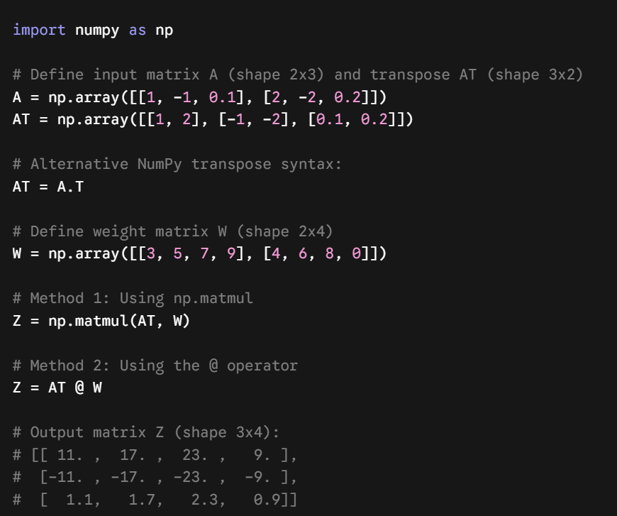
Dense Layer Vectorized Implementation
The slide shows the complete vectorized formulation for a single dense layer processing an input matrix.
Mathematical Formulation
For input feature matrix $A^{T}$, weight matrix $W$, and bias matrix $B$:

$$Z=A^{T}W+B$$
$$A^{\left[1\right]}=g\left(Z\right)$$

Parameter Values & Execution
- Input Matrix ($A^{T}$): Shape $\left(1×2\right)$, value $\left[\begin{matrix}200 & 17\end{matrix}\right]$.
- Weight Matrix ($W$): Shape $\left(2×3\right)$, value $\left[\begin{matrix}1 & -3 & 5 \\ -2 & 4 & -6\end{matrix}\right]$.
- Bias Matrix ($B$): Shape $\left(1×3\right)$, value $\left[\begin{matrix}-1 & 1 & 2\end{matrix}\right]$.
- Linear Activation ($Z$):
$$Z=\left[\begin{matrix}200 & 17\end{matrix}\right]\left[\begin{matrix}1 & -3 & 5 \\ -2 & 4 & -6\end{matrix}\right]+\left[\begin{matrix}-1 & 1 & 2\end{matrix}\right]=\left[\begin{matrix}165 & -531 & 900\end{matrix}\right]$$
- Activated Output ($A$): Passing $Z$ through sigmoid activation $g\left(Z\right)$ yields $\left[\begin{matrix}1 & 0 & 1\end{matrix}\right]$.

NumPy Function Implementation
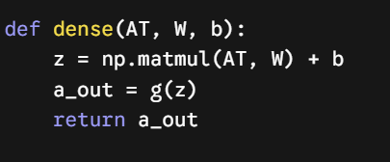
Key Takeaway
Vectorizing neural network layers replaces slow Python for loops with optimized matrix operations ($Z=A^{T}W+B$), leveraging linear algebra libraries like NumPy (np.matmul or @) to calculate layer activations across multiple units and training samples simultaneously.

2. Neural Network Training
Training Neural Networks in TensorFlow
High-level three-step programmatic workflow for constructing, configuring, and fitting a multi-layer deep neural network using TensorFlow and Keras. It connects network architectural diagrams to corresponding high-level Python API operations.
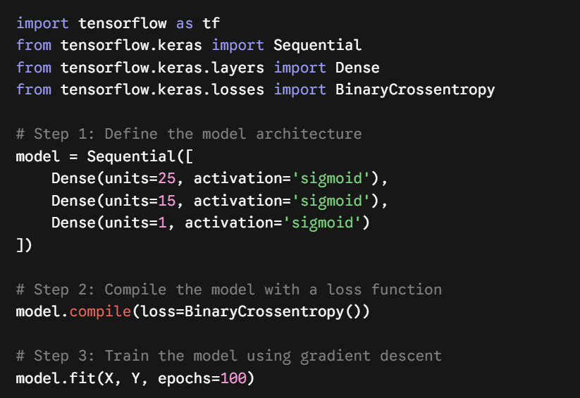
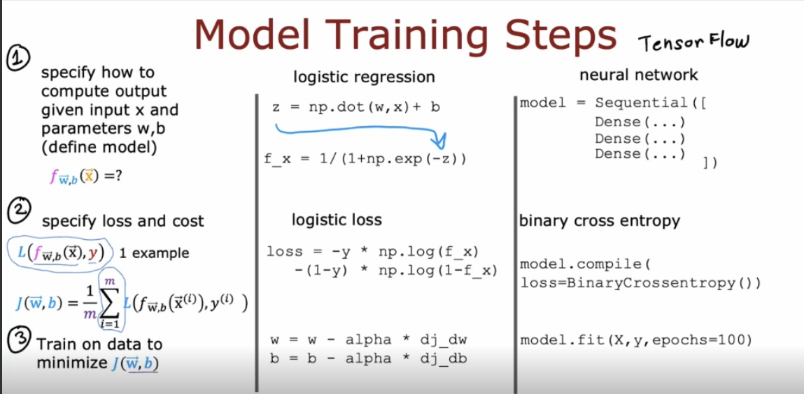

The Three-Step Workflow
- Step 1 (Model Creation): Instantiates a Sequential container wrapping three Dense layers with $25$, $15$, and $1$ units respectively, all using the sigmoid activation function.
- Step 2 (Loss Compilation): Configures model loss using model.compile(loss=BinaryCrossentropy()) to prepare the computational graph for binary classification.
- Step 3 (Model Fitting): Executes optimization on training feature data $X$ and targets $Y$ via model.fit(X, Y, epochs=100).

Parameter and Layer Summary
Network Layer | Number of Units | Activation Function | Layer Output Representation | TensorFlow Syntax
Layer 1 (Hidden) | $25$ units | Sigmoid ($g\left(z\right)$) | Activation vector ${\vec{a}}^{\left[1\right]}$ | Dense(units=25, activation='sigmoid')
Layer 2 (Hidden) | $15$ units | Sigmoid ($g\left(z\right)$) | Activation vector ${\vec{a}}^{\left[2\right]}$ | Dense(units=15, activation='sigmoid')
Layer 3 (Output) | $1$ unit | Sigmoid ($g\left(z\right)$) | Activation scalar ${\vec{a}}^{\left[3\right]}$ | Dense(units=1, activation='sigmoid')
Key Takeaway: Training a neural network in TensorFlow follows a structured three-part sequence: declaring network layers in a Sequential model, binding a loss function with compile(), and optimizing model weights over $100$ epochs using fit().

Neural Network Model Training Workflow vs. Logistic Regression
This slide compares the universal three-step machine learning training framework across two modeling approaches: classical logistic regression and deep neural networks in TensorFlow. It illustrates how representation, loss formulation, and parameter updates scale from linear models to deep architectures.

UNIVERSAL 3-STEP TRAINING BLUEPRINT
Step 1: Define Model Function ---> f_{w,b}(x)
Step 2: Specify Loss & Cost ---> Loss L(f(x), y) & Cost J(w,b) = (1/m) * sum(L)
Step 3: Train / Minimize Cost ---> Minimize J(w,b) via Gradient Descent
3-Step Blueprint Breakdown
- Step 1 — Define Model Function ($f_{\vec{w},b}\left(\vec{x}\right)$): Establishes the mathematical mapping from input features $\vec{x}$ to predicted values $\hat{y}$.
- Step 2 — Specify Loss and Cost:
  - Single-example Loss $L\left(f_{\vec{w},b}\left(\vec{x}\right),y\right)$: Measures error on an individual data point.
  - Dataset Cost $J\left(\vec{w},b\right)=\frac{1}{m}\sum_{i=1}^{m}{L}\left(f_{\vec{w},b}\left({\vec{x}}^{\left(i\right)}\right),y^{\left(i\right)}\right)$: Computes average loss over all $m$ training samples.
- Step 3 — Minimize Cost $J\left(\vec{w},b\right)$: Adjusts model parameters along negative gradients to reach minimal total loss.

Structural Comparison
Workflow Step | Step Objective | Logistic Regression Implementation | TensorFlow Neural Network Implementation
Step 1 | Define Model | $z=\vec{w}⋅\vec{x}+b$, $f\left(\vec{x}\right)=\frac{1}{1+e^{-z}}$ | model = Sequential([Dense(...), Dense(...), Dense(...)])
Step 2 | Specify Loss & Cost | $\text{loss}=-y\log\left(f\left(\vec{x}\right))-\left(1-y\right)\log\left(1-f\left(\vec{x}\right))\right)\right)$ | model.compile(loss=BinaryCrossentropy())
Step 3 | Parameter Optimization | $\vec{w}=\vec{w}-α\frac{∂J}{∂\vec{w}}$, $b=b-α\frac{∂J}{∂b}$ | model.fit(X, y, epochs=100)
Key Takeaway: Logistic regression and multi-layer neural networks share an identical fundamental training structure—model definition, loss selection, and cost minimization—differing primarily in parameter count and software abstraction.
Model Creation Steps:
Step 1: Model Definition in TensorFlow
This slide details Step 1 of the training pipeline: defining a multi-layer feedforward network architecture using tf.keras.Sequential and Dense layers. It maps structural network diagrams directly to Keras syntax.
Architectural Mapping & Parameters
- Input Vector ($\vec{x}$): Feeds raw feature inputs into the first hidden layer.
- Layer 1 ($25$ units): Takes input $\vec{x}$ and applies weight matrix $W^{\left[1\right]}$ and bias vector ${\vec{b}}^{\left[1\right]}$ to yield hidden activation ${\vec{a}}^{\left[1\right]}$. Defined as Dense(units=25, activation='sigmoid').
- Layer 2 ($15$ units): Takes intermediate activation vector ${\vec{a}}^{\left[1\right]}$ and applies weight matrix $W^{\left[2\right]}$ and bias vector ${\vec{b}}^{\left[2\right]}$ to output activation ${\vec{a}}^{\left[2\right]}$. Defined as Dense(units=15, activation='sigmoid').
- Layer 3 ($1$ unit): Takes activation vector ${\vec{a}}^{\left[2\right]}$ and applies weight matrix $W^{\left[3\right]}$ and bias vector ${\vec{b}}^{\left[3\right]}$ to produce final prediction scalar ${\vec{a}}^{\left[3\right]}=f\left(\vec{x}\right)$. Defined as Dense(units=1, activation='sigmoid').
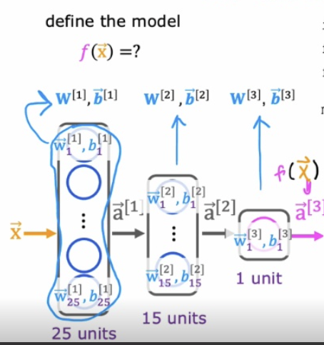
Layer Architecture and Keras Mapping
Layer Index | Unit Count | Layer Input | Layer Output | Parameters | Keras Code Syntax
Layer 1 | $25$ units | Input vector $\vec{x}$ | $${\vec{a}}^{\left[1\right]}$$ | $$W^{\left[1\right]},{\vec{b}}^{\left[1\right]}$$ | Dense(units=25, activation='sigmoid')
Layer 2 | $15$ units | Activation vector ${\vec{a}}^{\left[1\right]}$ | $${\vec{a}}^{\left[2\right]}$$ | $$W^{\left[2\right]},{\vec{b}}^{\left[2\right]}$$ | Dense(units=15, activation='sigmoid')
Layer 3 | $1$ unit | Activation vector ${\vec{a}}^{\left[2\right]}$ | $${\vec{a}}^{\left[3\right]}=f\left(\vec{x}\right)$$ | $$W^{\left[3\right]},{\vec{b}}^{\left[3\right]}$$ | Dense(units=1, activation='sigmoid')
Key Takeaway: In TensorFlow Keras, calling Sequential() with an ordered list of Dense layer objects constructs a computational graph where activations automatically flow sequentially from input to output.

Step 2: Loss and Cost Functions in TensorFlow
Step 2 of the workflow: selecting and compiling appropriate single-example loss functions $L\left(f\left(\vec{x}\right),y\right)$ and dataset cost functions $J\left(W,B\right)$ for classification and regression tasks.
Single-Example Loss vs. Dataset Cost
- Single-Example Loss ($L\left(f\left(\vec{x}\right),y\right)$): Computes prediction discrepancy for a single training sample.
- Dataset Cost Function ($J\left(W,B\right)$): Averages single-example losses across all $m$ samples and parameter matrices $W^{\left[1\right]},W^{\left[2\right]},W^{\left[3\right]}$ and bias vectors ${\vec{b}}^{\left[1\right]},{\vec{b}}^{\left[2\right]},{\vec{b}}^{\left[3\right]}$:

$$J\left(W,B\right)=\frac{1}{m}\sum_{i=1}^{m}{L}\left(f\left({\vec{x}}^{\left(i\right)}\right),y^{\left(i\right)}\right)$$
Task-Specific Loss Functions
- Binary Classification Problems (e.g., Handwritten Digit Detection):
  - Logistic Loss (Binary Cross-Entropy):

$$L\left(f\left(\vec{x}\right),y\right)=-y\log\left(f\left(\vec{x}\right))-\left(1-y\right)\log\left(1-f\left(\vec{x}\right))\right)\right)$$

  - TensorFlow Import & Compilation:
- Regression Problems (Predicting Continuous Numbers):
  - Mean Squared Error (MSE): Used when target $y$ is continuous rather than categorical.
  - TensorFlow Import & Compilation:
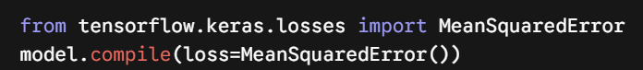

Loss Function Selection Summary
Problem Type | Target Variable Type | Single-Example Loss Formula | TensorFlow Loss Class | Compilation Command
Binary Classification | Binary label $y∈\left\{0,1\right\}$ | $-y\log\left(f\left(\vec{x}\right))-\left(1-y\right)\log\left(1-f\left(\vec{x}\right))\right)\right)$ | BinaryCrossentropy | model.compile(loss=BinaryCrossentropy())
Regression | Continuous value $y∈R$ | $$\frac{1}{2}{\left(f\left(\vec{x}\right)-y\right)}^{2}$$ | MeanSquaredError | model.compile(loss=MeanSquaredError())
Key Takeaway: Calling model.compile() binds a objective function to the network graph, configuring BinaryCrossentropy for binary targets or MeanSquaredError for continuous numerical predictions.

Step 3: Gradient Descent and Backpropagation in TensorFlow
Step 3 of model training: running gradient descent via backpropagation to minimize the global cost function $J\left(\vec{w},b\right)$ over a specified number of training epochs.
Gradient Descent Update Equations
For every layer index $l$ and unit index $j$, parameters are iteratively updated using computed partial derivatives:

$$w_{j}^{\left[l\right]}=w_{j}^{\left[l\right]}-α\frac{∂}{∂w_{j}^{\left[l\right]}}J\left(\vec{w},b\right)$$
$$b_{j}^{\left[l\right]}=b_{j}^{\left[l\right]}-α\frac{∂}{∂b_{j}^{\left[l\right]}}J\left(\vec{w},b\right)$$

- $α$ (Learning Rate): Positive scalar controlling step size during parameter updates.
- $\frac{∂J}{∂w_{j}^{\left[l\right]}},\frac{∂J}{∂b_{j}^{\left[l\right]}}$ (Partial Derivatives): Gradients of total cost $J\left(\vec{w},b\right)$ calculated via backpropagation.

Visual Optimization Curve
- Graph Axes: Plots overall cost $J\left(w\right)$ on the vertical axis against parameter weights $w$ on the horizontal axis.
- Optimization Steps: The blue curve shows the cost surface, while orange data markers illustrate parameter states descending step-by-step toward the minimum cost value.
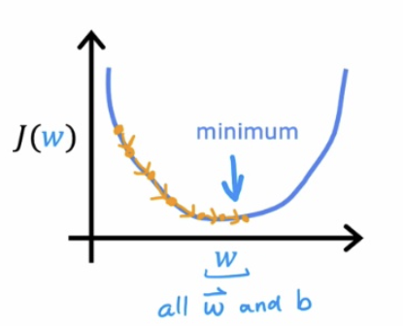

High-Level Training Command (model.fit)



